Scott Wiedemann
Auren Daniel Pierce
Project 5.1
Friday, November 20, 2009

The Data Mining Process with WEKA

Data Overview:

Below is a brief summary our data:

 | Location | Age at Diagnosis | Race or Ethnicity | Sex and Sexual Orientation | Vital Status
Type | Nominal | Nominal | Nominal | Nominal | Nominal
Distinct | 104 | 11 | 6 | 4 | 2

Location fields:
Akron OH
Albany-Schenectady NY
Albuquerque N.M.
Allentown PA
Ann Arbor MI
Atlanta GA
Austin TX
Bakersfield CA
Baltimore MD
Baton Rouge LA
Bergen-Passaic NJ
Birmingham AL
Boston MA
Buffalo NY
Charleston SC
Charlotte NC
Chicago IL
Cincinnati OH
Cleveland OH
Colorado Springs CO
Columbia SC
Columbus OH
Dallas TX
Dayton OH
Daytona Beach FL
Denver CO
Detroit MI
El Paso TX
Fort Lauderdale FL
Fort Wayne IN
Fort Worth TX
Fresno CA
Gary IN
Grand Rapids MI
Greensboro NC
Greenvile SC
Harrisburg PA
Hartford CT
Honolulu HI
Houston TX
Indianapolis IN
Jacksonville FL
Jersey City NJ
Kansas City MO
Knoxville TN
Las Vegas NV
Little Rock AR
Los Angeles CA
Louisville KY
McAllen-Edinburg-Mission TX
Memphis TN
Miami FL
Middlesex NJ
Milwaukee WI
Minneapolis-St Paul MN
Mobile Al
Monmouth-Ocean City NJ
Nashville TN
Nassau-Suffolk NY
New Haven CT
New Orleans LA
New York NY
Newark NJ
Norfolk VA
Oakland CA
Oklahoma City OK
Omaha NE
Orange County CA
Orlando FL
Philadelphia PA
Phoenix AZ
Pittsburgh PA
Portland OR
Providence RI
Raleigh-Durham NC
Richmond VA
Riverside-S Berndino CA
Rochester NY
Sacramento CA
Saint Louis MO
Salt Lake City UT
San Antonio TX
San Diego CA
San Francisco CA
San Jose CA
San Juan PR
Sarasota FL
Scranton PA
Seattle WA
Springfield MA
Stockton CA
Syracuse NY
Tacoma WA
Tampa-Saint Petersburg FL
Toledo OH
Tucson AZ
Tulsa OK
Vallejo-Fairfield-Napa CA
Ventura CA
Washington DC
West Palm Beach FL
Wichita KS
Wilmington DE
Youngstown OH

Age at Diagnosis fields:
13 - 19 Years
20 - 24 Years
25 - 29 Years
30 - 34 Years
35 - 39 Years or age is missing
40 - 44 Years
45 - 49 Years
50 - 54 Years
55 - 59 Years
60 - 64 Years
65+ Years

Race or Ethnicity fields:
Black (and also not Hispanic)
White (and also not Hispanic)
Hispanic
Unknown
Asian / Pacific Islander
American Indian / Alaskan Native

Sex and Sexual Orientation fields:
Male (bisexual)
Male (homosexual) or Unknown Classification
Male (heterosexual or pediatric)
Female (any)

Vital Status fields:
Alive: Not reported dead before 2001
Dead: Reported dead before 2001
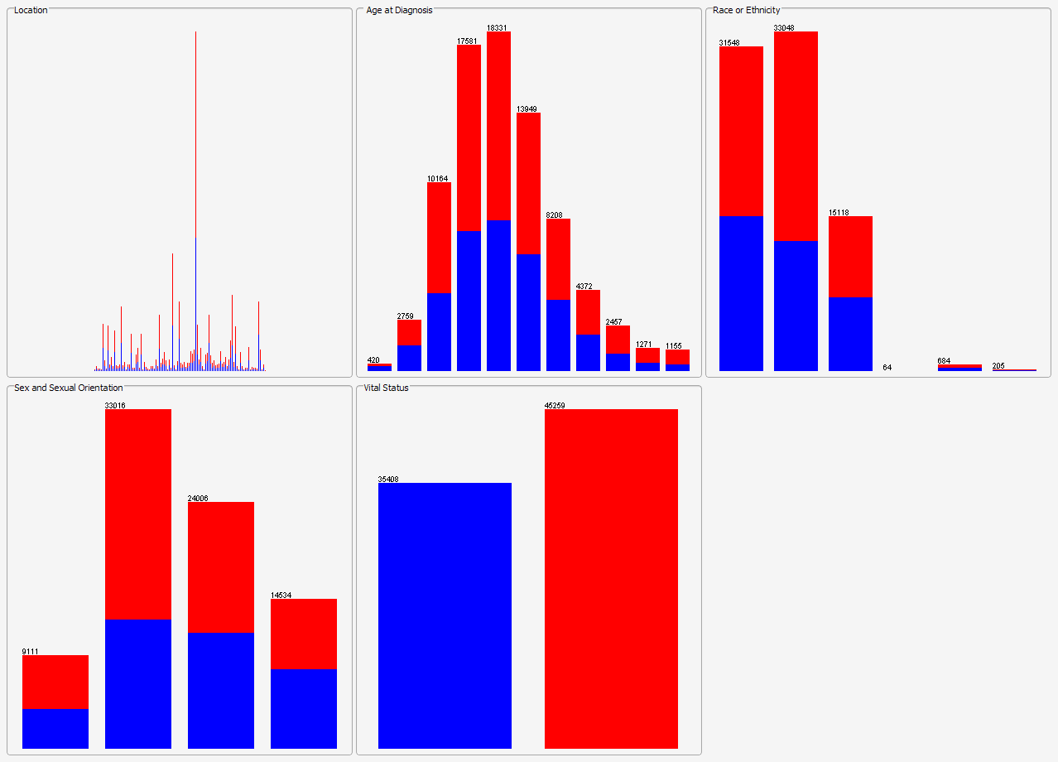
Figure 1

Detailed information is found in documentation.html, and should be referred to for a full understanding of the data, including its origin and collection.

Preprocessing:

The data we obtained was extracted from a database using a web interface that the CDC had created at http://wonder.cdc.gov/aids-v2002.html. We were only able to extract records with a total of five attributes through the GUI. We chose to look at sex, race, age at diagnosis, location, and vital status. The data that was given to us required a decent amount of preprocessing. All the attributes had been discretized and all of the duplicate records had been aggregated into a ‘total records’. We removed unnecessary fields and the total columns. The toughest job of the preprocessing was taking the aggregated records and creating individual instances. All of our manipulation was done using a DBMS, some clever SQL, PHP, and linux’s sed. We decided to do this in order for WEKA to easily interpret and process the data correctly and accurately.

By creating individual instances our data grew from about 40,000 records to 780,000 records. In order to easily process and play with the data in a timely manner, we created a randomized subset of the data with about 80,000 records. We will run classifiers on both the small dataset (the 80,000) and the larger dataset (the 780,000), but focus most of our attention on the smaller set in order to save time.

Goal:

We hope to find a relationship between an individuals sex, race, location and what age they were diagnosed with HIV at, and their vital status. We would also like to see which groups are at highest risk of contracting HIV, regardless of their vital status.

Process, Strategies and Algorithms:

We will be using WEKA as our primary data mining tool. Our first approaches looked at tree classifiers (J48). I believe our data lends itself to a tree structure, considering the quantity and distribution of attributes. Using knowledge flow, we performed an exhaustive removal of all the attributes, while running the J48 classifier. We were hoping to find which attributes contributed the most knowledge gain to the tree. Refer to the details and results section for the output and analysis of the experimentation. After experimenting with other tree structures and obtaining poor results we decided to shift our focus. Predicting the vital status from the characteristics of an individual with HIV or AIDS may not be possible, or that meaningful. (The fact that one is dead may not be the result of HIV or AIDS as well.)

Instead, we decided to disregard vital status and see if we could detect which groups of people are at highest risk for getting HIV and AIDS. Articles online that cite the CDC’s HIV data, claim the black, gay young men are at highest risk of contracting HIV.** We will attempt to either back or question these claims. In order to determine the risk groups, we used basic clustering algorithms, while ignoring vital status. A clustering classifier based on sex and sexual orientation, age at diagnosis, and race or ethnicity should tell us what groups are most prevalent in the dataset.

We are using EM clustering and simple k means. EM assigns a probability distribution to each instance which indicates the probability of it belonging to each of the clusters. For k means, we used 2, 3, 4, and 5 k clusters. Our results were reasonable. We used EM’s unsupervised cross validation method to automatically create the number of clusters. We also looked at WEKA’S only hierarchical clustering algorithm, COBWEB.

Details and Results:

We were disappointed with the J48 and other tree classifiers. We ran some SQL and discovered that if a classifier were to randomly pick the vital status based on the distribution of records, 56.11% would be classified as dead and 43.89% as alive. We were hoping that a tree classifier could significantly improve this. The trees generated by J48 made splits as we would have expected.

The basic hierarchy of the trees is as such:

|-Sex and Sexual Orientation
|---------Location
|-------------------Age at Diagnosis
|-----------------------------Race or Ethnicity

After examining all of the J48 trees generated by our weak knowledge flow, we found that all of the trees that had only one attribute removed fell within 1.5% of each other. The best result was the tree with no attributes removed which correctly classified instances 58.9745 % of the time, only 2.86% better than a classifier that would always pick dead as the vital status.

Full results of typical J48 on small dataset with no attributes removed:

=== Run information ===

Scheme: weka.classifiers.trees.J48 -C 0.25 -M 2
Relation: project_5.1_small
Instances: 80667
Attributes: 5
Location
Age at Diagnosis
Race or Ethnicity
Sex and Sexual Orientation
Vital Status
Test mode: 10-fold cross-validation

=== Classifier model (full training set) ===

J48 pruned tree
------------------

Sex and Sexual Orientation = Male (bisexual)
| Location = Akron OH: Dead: Reported dead before 2001 (14.0/6.0)
| Location = Albany-Schenectady NY: Dead: Reported dead before 2001 (20.0/8.0)
| Location = Albuquerque N.M.: Dead: Reported dead before 2001 (26.0/7.0)
| Location = Allentown PA: Alive: Not reported dead before 2001 (7.0/3.0)
| Location = Ann Arbor MI: Dead: Reported dead before 2001 (13.0/4.0)
| Location = Atlanta GA
| | Age at Diagnosis = 13 - 19 Years: Alive: Not reported dead before 2001 (1.0)
| | Age at Diagnosis = 20 - 24 Years: Alive: Not reported dead before 2001 (10.0/3.0)
| | Age at Diagnosis = 25 - 29 Years: Dead: Reported dead before 2001 (40.0/14.0)
| | Age at Diagnosis = 30 - 34 Years
| | | Race or Ethnicity = Black (and also not Hispanic): Alive: Not reported dead before 2001 (43.0/21.0)
| | | Race or Ethnicity = White (and also not Hispanic): Dead: Reported dead before 2001 (23.0/9.0)
| | | Race or Ethnicity = Hispanic: Alive: Not reported dead before 2001 (2.0)
| | | Race or Ethnicity = Unknown: Dead: Reported dead before 2001 (0.0)
| | | Race or Ethnicity = Asian / Pacific Islander: Dead: Reported dead before 2001 (0.0)
| | | Race or Ethnicity = American Indian /Alaskan Native: Dead: Reported dead before 2001 (0.0)
| | Age at Diagnosis = 35 - 39 Years or age is missing: Alive: Not reported dead before 2001 (78.0/31.0)
| | Age at Diagnosis = 40 - 44 Years: Alive: Not reported dead before 2001 (38.0/17.0)
| | Age at Diagnosis = 45 - 49 Years
| | | Race or Ethnicity = Black (and also not Hispanic): Alive: Not reported dead before 2001 (7.0/2.0)
| | | Race or Ethnicity = White (and also not Hispanic): Dead: Reported dead before 2001 (12.0/3.0)
| | | Race or Ethnicity = Hispanic: Dead: Reported dead before 2001 (1.0)
| | | Race or Ethnicity = Unknown: Dead: Reported dead before 2001 (0.0)
| | | Race or Ethnicity = Asian / Pacific Islander: Dead: Reported dead before 2001 (0.0)
| | | Race or Ethnicity = American Indian /Alaskan Native: Dead: Reported dead before 2001 (0.0)
| | Age at Diagnosis = 50 - 54 Years
| | | Race or Ethnicity = Black (and also not Hispanic): Dead: Reported dead before 2001 (8.0/2.0)
| | | Race or Ethnicity = White (and also not Hispanic): Alive: Not reported dead before 2001 (3.0/1.0)
| | | Race or Ethnicity = Hispanic: Dead: Reported dead before 2001 (0.0)
| | | Race or Ethnicity = Unknown: Dead: Reported dead before 2001 (0.0)
| | | Race or Ethnicity = Asian / Pacific Islander: Dead: Reported dead before 2001 (0.0)
| | | Race or Ethnicity = American Indian /Alaskan Native: Dead: Reported dead before 2001 (0.0)
| | Age at Diagnosis = 55 - 59 Years: Alive: Not reported dead before 2001 (4.0/2.0)
| | Age at Diagnosis = 60 - 64 Years
| | | Race or Ethnicity = Black (and also not Hispanic): Alive: Not reported dead before 2001 (2.0)
| | | Race or Ethnicity = White (and also not Hispanic): Dead: Reported dead before 2001 (4.0/1.0)
| | | Race or Ethnicity = Hispanic: Alive: Not reported dead before 2001 (0.0)
| | | Race or Ethnicity = Unknown: Alive: Not reported dead before 2001 (0.0)
| | | Race or Ethnicity = Asian / Pacific Islander: Alive: Not reported dead before 2001 (0.0)
| | | Race or Ethnicity = American Indian /Alaskan Native: Alive: Not reported dead before 2001 (0.0)
| | Age at Diagnosis = 65+ Years: Dead: Reported dead before 2001 (1.0)
| Location = Austin TX: Alive: Not reported dead before 2001 (46.0/17.0)
| Location = Bakersfield CA: Dead: Reported dead before 2001 (32.0/14.0)
| Location = Baltimore MD: Dead: Reported dead before 2001 (165.0/66.0)
| Location = Baton Rouge LA
| | Race or Ethnicity = Black (and also not Hispanic): Alive: Not reported dead before 2001 (16.0/3.0)
| | Race or Ethnicity = White (and also not Hispanic): Dead: Reported dead before 2001 (11.0/1.0)
| | Race or Ethnicity = Hispanic: Alive: Not reported dead before 2001 (0.0)
| | Race or Ethnicity = Unknown: Alive: Not reported dead before 2001 (0.0)
| | Race or Ethnicity = Asian / Pacific Islander: Alive: Not reported dead before 2001 (0.0)
| | Race or Ethnicity = American Indian /Alaskan Native: Alive: Not reported dead before 2001 (0.0)
| Location = Bergen-Passaic NJ: Dead: Reported dead before 2001 (50.0/17.0)
| Location = Birmingham AL
| | Age at Diagnosis = 13 - 19 Years: Dead: Reported dead before 2001 (0.0)
| | Age at Diagnosis = 20 - 24 Years: Alive: Not reported dead before 2001 (1.0)
| | Age at Diagnosis = 25 - 29 Years: Dead: Reported dead before 2001 (6.0)
| | Age at Diagnosis = 30 - 34 Years: Alive: Not reported dead before 2001 (10.0/3.0)
| | Age at Diagnosis = 35 - 39 Years or age is missing: Dead: Reported dead before 2001 (9.0/2.0)
| | Age at Diagnosis = 40 - 44 Years: Alive: Not reported dead before 2001 (7.0/2.0)
| | Age at Diagnosis = 45 - 49 Years: Alive: Not reported dead before 2001 (6.0/2.0)
| | Age at Diagnosis = 50 - 54 Years: Alive: Not reported dead before 2001 (2.0/1.0)
| | Age at Diagnosis = 55 - 59 Years: Dead: Reported dead before 2001 (0.0)
| | Age at Diagnosis = 60 - 64 Years: Dead: Reported dead before 2001 (0.0)
| | Age at Diagnosis = 65+ Years: Dead: Reported dead before 2001 (0.0)
| Location = Boston MA: Dead: Reported dead before 2001 (110.0/40.0)
| Location = Buffalo NY: Dead: Reported dead before 2001 (5.0/2.0)
| Location = Charleston SC: Dead: Reported dead before 2001 (30.0/13.0)
| Location = Charlotte NC: Alive: Not reported dead before 2001 (34.0/16.0)
| Location = Chicago IL
| | Race or Ethnicity = Black (and also not Hispanic): Dead: Reported dead before 2001 (188.0/89.0)
| | Race or Ethnicity = White (and also not Hispanic): Dead: Reported dead before 2001 (101.0/29.0)
| | Race or Ethnicity = Hispanic
| | | Age at Diagnosis = 13 - 19 Years: Alive: Not reported dead before 2001 (0.0)
| | | Age at Diagnosis = 20 - 24 Years: Dead: Reported dead before 2001 (1.0)
| | | Age at Diagnosis = 25 - 29 Years: Alive: Not reported dead before 2001 (11.0/3.0)
| | | Age at Diagnosis = 30 - 34 Years: Alive: Not reported dead before 2001 (14.0/5.0)
| | | Age at Diagnosis = 35 - 39 Years or age is missing: Dead: Reported dead before 2001 (11.0/4.0)
| | | Age at Diagnosis = 40 - 44 Years: Alive: Not reported dead before 2001 (4.0/2.0)
| | | Age at Diagnosis = 45 - 49 Years: Alive: Not reported dead before 2001 (6.0/1.0)
| | | Age at Diagnosis = 50 - 54 Years: Dead: Reported dead before 2001 (3.0)
| | | Age at Diagnosis = 55 - 59 Years: Alive: Not reported dead before 2001 (1.0)
| | | Age at Diagnosis = 60 - 64 Years: Dead: Reported dead before 2001 (2.0)
| | | Age at Diagnosis = 65+ Years: Alive: Not reported dead before 2001 (0.0)
| | Race or Ethnicity = Unknown: Dead: Reported dead before 2001 (0.0)
| | Race or Ethnicity = Asian / Pacific Islander: Alive: Not reported dead before 2001 (1.0)
| | Race or Ethnicity = American Indian /Alaskan Native: Alive: Not reported dead before 2001 (1.0)
| Location = Cincinnati OH: Alive: Not reported dead before 2001 (43.0/21.0)
| Location = Cleveland OH
| | Race or Ethnicity = Black (and also not Hispanic): Alive: Not reported dead before 2001 (41.0/19.0)
| | Race or Ethnicity = White (and also not Hispanic): Dead: Reported dead before 2001 (24.0/5.0)
| | Race or Ethnicity = Hispanic: Dead: Reported dead before 2001 (3.0)
| | Race or Ethnicity = Unknown: Dead: Reported dead before 2001 (0.0)
| | Race or Ethnicity = Asian / Pacific Islander: Alive: Not reported dead before 2001 (1.0)
| | Race or Ethnicity = American Indian /Alaskan Native: Dead: Reported dead before 2001 (0.0)
| Location = Colorado Springs CO: Alive: Not reported dead before 2001 (16.0/7.0)
| Location = Columbia SC: Alive: Not reported dead before 2001 (50.0/23.0)
| Location = Columbus OH: Dead: Reported dead before 2001 (50.0/18.0)
| Location = Dallas TX: Alive: Not reported dead before 2001 (321.0/123.0)
| Location = Dayton OH: Dead: Reported dead before 2001 (24.0/11.0)
| Location = Daytona Beach FL: Dead: Reported dead before 2001 (20.0/9.0)
| Location = Denver CO: Dead: Reported dead before 2001 (109.0/52.0)
| Location = Detroit MI: Dead: Reported dead before 2001 (204.0/77.0)
| Location = El Paso TX: Alive: Not reported dead before 2001 (18.0/4.0)
| Location = Fort Lauderdale FL: Dead: Reported dead before 2001 (187.0/74.0)
| Location = Fort Wayne IN: Alive: Not reported dead before 2001 (13.0/5.0)
| Location = Fort Worth TX
| | Race or Ethnicity = Black (and also not Hispanic): Dead: Reported dead before 2001 (11.0/1.0)
| | Race or Ethnicity = White (and also not Hispanic)
| | | Age at Diagnosis = 13 - 19 Years: Dead: Reported dead before 2001 (0.0)
| | | Age at Diagnosis = 20 - 24 Years: Dead: Reported dead before 2001 (0.0)
| | | Age at Diagnosis = 25 - 29 Years: Alive: Not reported dead before 2001 (4.0/2.0)
| | | Age at Diagnosis = 30 - 34 Years: Alive: Not reported dead before 2001 (8.0/3.0)
| | | Age at Diagnosis = 35 - 39 Years or age is missing: Alive: Not reported dead before 2001 (6.0/2.0)
| | | Age at Diagnosis = 40 - 44 Years: Dead: Reported dead before 2001 (7.0/1.0)
| | | Age at Diagnosis = 45 - 49 Years: Alive: Not reported dead before 2001 (2.0/1.0)
| | | Age at Diagnosis = 50 - 54 Years: Dead: Reported dead before 2001 (0.0)
| | | Age at Diagnosis = 55 - 59 Years: Dead: Reported dead before 2001 (0.0)
| | | Age at Diagnosis = 60 - 64 Years: Dead: Reported dead before 2001 (0.0)
| | | Age at Diagnosis = 65+ Years: Dead: Reported dead before 2001 (0.0)
| | Race or Ethnicity = Hispanic: Alive: Not reported dead before 2001 (2.0)
| | Race or Ethnicity = Unknown: Dead: Reported dead before 2001 (0.0)
| | Race or Ethnicity = Asian / Pacific Islander: Dead: Reported dead before 2001 (0.0)
| | Race or Ethnicity = American Indian /Alaskan Native: Dead: Reported dead before 2001 (0.0)
| Location = Fresno CA
| | Race or Ethnicity = Black (and also not Hispanic): Alive: Not reported dead before 2001 (3.0/1.0)
| | Race or Ethnicity = White (and also not Hispanic): Dead: Reported dead before 2001 (21.0/6.0)
| | Race or Ethnicity = Hispanic: Alive: Not reported dead before 2001 (12.0/4.0)
| | Race or Ethnicity = Unknown: Dead: Reported dead before 2001 (0.0)
| | Race or Ethnicity = Asian / Pacific Islander: Alive: Not reported dead before 2001 (1.0)
| | Race or Ethnicity = American Indian /Alaskan Native: Dead: Reported dead before 2001 (1.0)
| Location = Gary IN: Alive: Not reported dead before 2001 (21.0/10.0)
| Location = Grand Rapids MI: Dead: Reported dead before 2001 (14.0/2.0)
| Location = Greensboro NC: Dead: Reported dead before 2001 (31.0/11.0)
| Location = Greenvile SC: Dead: Reported dead before 2001 (50.0/21.0)
| Location = Harrisburg PA: Alive: Not reported dead before 2001 (24.0/12.0)
| Location = Hartford CT: Dead: Reported dead before 2001 (28.0/11.0)
| Location = Honolulu HI: Dead: Reported dead before 2001 (22.0/6.0)
| Location = Houston TX: Dead: Reported dead before 2001 (246.0/110.0)
| Location = Indianapolis IN
| | Race or Ethnicity = Black (and also not Hispanic): Alive: Not reported dead before 2001 (13.0/2.0)
| | Race or Ethnicity = White (and also not Hispanic): Dead: Reported dead before 2001 (34.0/12.0)
| | Race or Ethnicity = Hispanic: Alive: Not reported dead before 2001 (1.0)
| | Race or Ethnicity = Unknown: Alive: Not reported dead before 2001 (0.0)
| | Race or Ethnicity = Asian / Pacific Islander: Alive: Not reported dead before 2001 (0.0)
| | Race or Ethnicity = American Indian /Alaskan Native: Alive: Not reported dead before 2001 (0.0)
| Location = Jacksonville FL: Alive: Not reported dead before 2001 (101.0/48.0)
| Location = Jersey City NJ
| | Race or Ethnicity = Black (and also not Hispanic): Alive: Not reported dead before 2001 (18.0/9.0)
| | Race or Ethnicity = White (and also not Hispanic): Dead: Reported dead before 2001 (11.0/3.0)
| | Race or Ethnicity = Hispanic: Alive: Not reported dead before 2001 (24.0/9.0)
| | Race or Ethnicity = Unknown: Alive: Not reported dead before 2001 (0.0)
| | Race or Ethnicity = Asian / Pacific Islander: Dead: Reported dead before 2001 (1.0)
| | Race or Ethnicity = American Indian /Alaskan Native: Alive: Not reported dead before 2001 (1.0)
| Location = Kansas City MO
| | Age at Diagnosis = 13 - 19 Years: Dead: Reported dead before 2001 (0.0)
| | Age at Diagnosis = 20 - 24 Years: Dead: Reported dead before 2001 (6.0/1.0)
| | Age at Diagnosis = 25 - 29 Years: Dead: Reported dead before 2001 (17.0/6.0)
| | Age at Diagnosis = 30 - 34 Years: Alive: Not reported dead before 2001 (23.0/11.0)
| | Age at Diagnosis = 35 - 39 Years or age is missing: Alive: Not reported dead before 2001 (14.0/4.0)
| | Age at Diagnosis = 40 - 44 Years: Alive: Not reported dead before 2001 (9.0/2.0)
| | Age at Diagnosis = 45 - 49 Years: Dead: Reported dead before 2001 (9.0/1.0)
| | Age at Diagnosis = 50 - 54 Years: Alive: Not reported dead before 2001 (4.0/2.0)
| | Age at Diagnosis = 55 - 59 Years: Dead: Reported dead before 2001 (3.0)
| | Age at Diagnosis = 60 - 64 Years: Dead: Reported dead before 2001 (2.0)
| | Age at Diagnosis = 65+ Years: Dead: Reported dead before 2001 (1.0)
| Location = Knoxville TN: Dead: Reported dead before 2001 (19.0/8.0)
| Location = Las Vegas NV
| | Age at Diagnosis = 13 - 19 Years: Dead: Reported dead before 2001 (0.0)
| | Age at Diagnosis = 20 - 24 Years: Alive: Not reported dead before 2001 (1.0)
| | Age at Diagnosis = 25 - 29 Years
| | | Race or Ethnicity = Black (and also not Hispanic): Dead: Reported dead before 2001 (3.0)
| | | Race or Ethnicity = White (and also not Hispanic): Dead: Reported dead before 2001 (3.0)
| | | Race or Ethnicity = Hispanic: Alive: Not reported dead before 2001 (4.0/1.0)
| | | Race or Ethnicity = Unknown: Dead: Reported dead before 2001 (0.0)
| | | Race or Ethnicity = Asian / Pacific Islander: Dead: Reported dead before 2001 (0.0)
| | | Race or Ethnicity = American Indian /Alaskan Native: Dead: Reported dead before 2001 (0.0)
| | Age at Diagnosis = 30 - 34 Years: Alive: Not reported dead before 2001 (23.0/11.0)
| | Age at Diagnosis = 35 - 39 Years or age is missing: Alive: Not reported dead before 2001 (16.0/6.0)
| | Age at Diagnosis = 40 - 44 Years: Dead: Reported dead before 2001 (15.0/4.0)
| | Age at Diagnosis = 45 - 49 Years: Alive: Not reported dead before 2001 (12.0/4.0)
| | Age at Diagnosis = 50 - 54 Years: Alive: Not reported dead before 2001 (5.0/2.0)
| | Age at Diagnosis = 55 - 59 Years: Dead: Reported dead before 2001 (3.0/1.0)
| | Age at Diagnosis = 60 - 64 Years: Dead: Reported dead before 2001 (3.0/1.0)
| | Age at Diagnosis = 65+ Years: Dead: Reported dead before 2001 (1.0)
| Location = Little Rock AR: Dead: Reported dead before 2001 (28.0/12.0)
| Location = Los Angeles CA: Dead: Reported dead before 2001 (659.0/233.0)
| Location = Louisville KY: Alive: Not reported dead before 2001 (36.0/15.0)
| Location = McAllen-Edinburg-Mission TX: Alive: Not reported dead before 2001 (8.0/4.0)
| Location = Memphis TN
| | Age at Diagnosis = 13 - 19 Years: Alive: Not reported dead before 2001 (0.0)
| | Age at Diagnosis = 20 - 24 Years: Dead: Reported dead before 2001 (2.0)
| | Age at Diagnosis = 25 - 29 Years: Dead: Reported dead before 2001 (15.0/4.0)
| | Age at Diagnosis = 30 - 34 Years: Dead: Reported dead before 2001 (21.0/9.0)
| | Age at Diagnosis = 35 - 39 Years or age is missing: Dead: Reported dead before 2001 (15.0/5.0)
| | Age at Diagnosis = 40 - 44 Years: Alive: Not reported dead before 2001 (19.0/4.0)
| | Age at Diagnosis = 45 - 49 Years: Alive: Not reported dead before 2001 (11.0/3.0)
| | Age at Diagnosis = 50 - 54 Years: Alive: Not reported dead before 2001 (5.0/1.0)
| | Age at Diagnosis = 55 - 59 Years: Alive: Not reported dead before 2001 (0.0)
| | Age at Diagnosis = 60 - 64 Years: Alive: Not reported dead before 2001 (0.0)
| | Age at Diagnosis = 65+ Years: Alive: Not reported dead before 2001 (3.0/1.0)
| Location = Miami FL: Dead: Reported dead before 2001 (305.0/115.0)
| Location = Middlesex NJ: Dead: Reported dead before 2001 (24.0/10.0)
| Location = Milwaukee WI: Dead: Reported dead before 2001 (57.0/27.0)
| Location = Minneapolis-St Paul MN: Dead: Reported dead before 2001 (80.0/36.0)
| Location = Mobile Al: Alive: Not reported dead before 2001 (24.0/11.0)
| Location = Monmouth-Ocean City NJ: Dead: Reported dead before 2001 (28.0/10.0)
| Location = Nashville TN
| | Race or Ethnicity = Black (and also not Hispanic): Alive: Not reported dead before 2001 (15.0/2.0)
| | Race or Ethnicity = White (and also not Hispanic): Dead: Reported dead before 2001 (18.0/7.0)
| | Race or Ethnicity = Hispanic: Alive: Not reported dead before 2001 (0.0)
| | Race or Ethnicity = Unknown: Alive: Not reported dead before 2001 (0.0)
| | Race or Ethnicity = Asian / Pacific Islander: Alive: Not reported dead before 2001 (0.0)
| | Race or Ethnicity = American Indian /Alaskan Native: Alive: Not reported dead before 2001 (0.0)
| Location = Nassau-Suffolk NY: Dead: Reported dead before 2001 (79.0/27.0)
| Location = New Haven CT: Dead: Reported dead before 2001 (38.0/17.0)
| Location = New Orleans LA: Dead: Reported dead before 2001 (124.0/50.0)
| Location = New York NY: Dead: Reported dead before 2001 (773.0/239.0)
| Location = Newark NJ: Dead: Reported dead before 2001 (118.0/35.0)
| Location = Norfolk VA: Alive: Not reported dead before 2001 (83.0/29.0)
| Location = Oakland CA: Dead: Reported dead before 2001 (146.0/47.0)
| Location = Oklahoma City OK: Dead: Reported dead before 2001 (53.0/21.0)
| Location = Omaha NE
| | Race or Ethnicity = Black (and also not Hispanic): Alive: Not reported dead before 2001 (4.0/1.0)
| | Race or Ethnicity = White (and also not Hispanic): Dead: Reported dead before 2001 (8.0/3.0)
| | Race or Ethnicity = Hispanic: Dead: Reported dead before 2001 (1.0)
| | Race or Ethnicity = Unknown: Dead: Reported dead before 2001 (0.0)
| | Race or Ethnicity = Asian / Pacific Islander: Dead: Reported dead before 2001 (0.0)
| | Race or Ethnicity = American Indian /Alaskan Native: Dead: Reported dead before 2001 (0.0)
| Location = Orange County CA
| | Race or Ethnicity = Black (and also not Hispanic): Alive: Not reported dead before 2001 (8.0/4.0)
| | Race or Ethnicity = White (and also not Hispanic): Dead: Reported dead before 2001 (88.0/32.0)
| | Race or Ethnicity = Hispanic: Alive: Not reported dead before 2001 (36.0/11.0)
| | Race or Ethnicity = Unknown: Dead: Reported dead before 2001 (0.0)
| | Race or Ethnicity = Asian / Pacific Islander: Alive: Not reported dead before 2001 (2.0/1.0)
| | Race or Ethnicity = American Indian /Alaskan Native: Dead: Reported dead before 2001 (0.0)
| Location = Orlando FL
| | Race or Ethnicity = Black (and also not Hispanic): Alive: Not reported dead before 2001 (66.0/25.0)
| | Race or Ethnicity = White (and also not Hispanic): Dead: Reported dead before 2001 (67.0/31.0)
| | Race or Ethnicity = Hispanic: Alive: Not reported dead before 2001 (21.0/5.0)
| | Race or Ethnicity = Unknown: Alive: Not reported dead before 2001 (0.0)
| | Race or Ethnicity = Asian / Pacific Islander: Alive: Not reported dead before 2001 (0.0)
| | Race or Ethnicity = American Indian /Alaskan Native: Dead: Reported dead before 2001 (1.0)
| Location = Philadelphia PA: Dead: Reported dead before 2001 (266.0/114.0)
| Location = Phoenix AZ
| | Race or Ethnicity = Black (and also not Hispanic): Alive: Not reported dead before 2001 (7.0/1.0)
| | Race or Ethnicity = White (and also not Hispanic): Dead: Reported dead before 2001 (81.0/28.0)
| | Race or Ethnicity = Hispanic: Dead: Reported dead before 2001 (27.0/10.0)
| | Race or Ethnicity = Unknown: Dead: Reported dead before 2001 (1.0)
| | Race or Ethnicity = Asian / Pacific Islander: Dead: Reported dead before 2001 (1.0)
| | Race or Ethnicity = American Indian /Alaskan Native: Alive: Not reported dead before 2001 (2.0)
| Location = Pittsburgh PA: Dead: Reported dead before 2001 (45.0/15.0)
| Location = Portland OR: Dead: Reported dead before 2001 (59.0/24.0)
| Location = Providence RI: Alive: Not reported dead before 2001 (24.0/9.0)
| Location = Raleigh-Durham NC: Alive: Not reported dead before 2001 (36.0/15.0)
| Location = Richmond VA: Dead: Reported dead before 2001 (28.0/11.0)
| Location = Riverside-S Berndino CA
| | Race or Ethnicity = Black (and also not Hispanic): Alive: Not reported dead before 2001 (24.0/7.0)
| | Race or Ethnicity = White (and also not Hispanic): Dead: Reported dead before 2001 (90.0/39.0)
| | Race or Ethnicity = Hispanic: Dead: Reported dead before 2001 (35.0/17.0)
| | Race or Ethnicity = Unknown: Dead: Reported dead before 2001 (0.0)
| | Race or Ethnicity = Asian / Pacific Islander: Dead: Reported dead before 2001 (3.0/1.0)
| | Race or Ethnicity = American Indian /Alaskan Native: Alive: Not reported dead before 2001 (3.0)
| Location = Rochester NY: Alive: Not reported dead before 2001 (23.0/10.0)
| Location = Sacramento CA: Dead: Reported dead before 2001 (63.0/23.0)
| Location = Saint Louis MO
| | Race or Ethnicity = Black (and also not Hispanic): Alive: Not reported dead before 2001 (46.0/19.0)
| | Race or Ethnicity = White (and also not Hispanic): Dead: Reported dead before 2001 (63.0/23.0)
| | Race or Ethnicity = Hispanic: Alive: Not reported dead before 2001 (2.0)
| | Race or Ethnicity = Unknown: Dead: Reported dead before 2001 (0.0)
| | Race or Ethnicity = Asian / Pacific Islander: Dead: Reported dead before 2001 (0.0)
| | Race or Ethnicity = American Indian /Alaskan Native: Dead: Reported dead before 2001 (0.0)
| Location = Salt Lake City UT: Alive: Not reported dead before 2001 (27.0/6.0)
| Location = San Antonio TX: Dead: Reported dead before 2001 (58.0/25.0)
| Location = San Diego CA
| | Age at Diagnosis = 13 - 19 Years: Dead: Reported dead before 2001 (0.0)
| | Age at Diagnosis = 20 - 24 Years: Dead: Reported dead before 2001 (9.0/3.0)
| | Age at Diagnosis = 25 - 29 Years: Dead: Reported dead before 2001 (32.0/12.0)
| | Age at Diagnosis = 30 - 34 Years
| | | Race or Ethnicity = Black (and also not Hispanic): Dead: Reported dead before 2001 (10.0/4.0)
| | | Race or Ethnicity = White (and also not Hispanic): Dead: Reported dead before 2001 (20.0/7.0)
| | | Race or Ethnicity = Hispanic: Alive: Not reported dead before 2001 (13.0/4.0)
| | | Race or Ethnicity = Unknown: Dead: Reported dead before 2001 (0.0)
| | | Race or Ethnicity = Asian / Pacific Islander: Dead: Reported dead before 2001 (1.0)
| | | Race or Ethnicity = American Indian /Alaskan Native: Dead: Reported dead before 2001 (0.0)
| | Age at Diagnosis = 35 - 39 Years or age is missing: Alive: Not reported dead before 2001 (43.0/18.0)
| | Age at Diagnosis = 40 - 44 Years
| | | Race or Ethnicity = Black (and also not Hispanic): Alive: Not reported dead before 2001 (6.0/2.0)
| | | Race or Ethnicity = White (and also not Hispanic): Dead: Reported dead before 2001 (20.0/8.0)
| | | Race or Ethnicity = Hispanic: Alive: Not reported dead before 2001 (7.0/2.0)
| | | Race or Ethnicity = Unknown: Alive: Not reported dead before 2001 (0.0)
| | | Race or Ethnicity = Asian / Pacific Islander: Alive: Not reported dead before 2001 (0.0)
| | | Race or Ethnicity = American Indian /Alaskan Native: Alive: Not reported dead before 2001 (0.0)
| | Age at Diagnosis = 45 - 49 Years
| | | Race or Ethnicity = Black (and also not Hispanic): Alive: Not reported dead before 2001 (3.0/1.0)
| | | Race or Ethnicity = White (and also not Hispanic): Dead: Reported dead before 2001 (15.0/5.0)
| | | Race or Ethnicity = Hispanic: Alive: Not reported dead before 2001 (4.0/1.0)
| | | Race or Ethnicity = Unknown: Dead: Reported dead before 2001 (0.0)
| | | Race or Ethnicity = Asian / Pacific Islander: Dead: Reported dead before 2001 (0.0)
| | | Race or Ethnicity = American Indian /Alaskan Native: Dead: Reported dead before 2001 (0.0)
| | Age at Diagnosis = 50 - 54 Years: Alive: Not reported dead before 2001 (12.0/4.0)
| | Age at Diagnosis = 55 - 59 Years: Dead: Reported dead before 2001 (5.0)
| | Age at Diagnosis = 60 - 64 Years: Alive: Not reported dead before 2001 (5.0/1.0)
| | Age at Diagnosis = 65+ Years: Dead: Reported dead before 2001 (3.0)
| Location = San Francisco CA: Dead: Reported dead before 2001 (295.0/104.0)
| Location = San Jose CA: Dead: Reported dead before 2001 (62.0/26.0)
| Location = San Juan PR: Dead: Reported dead before 2001 (187.0/78.0)
| Location = Sarasota FL
| | Race or Ethnicity = Black (and also not Hispanic): Alive: Not reported dead before 2001 (5.0/2.0)
| | Race or Ethnicity = White (and also not Hispanic): Dead: Reported dead before 2001 (26.0/4.0)
| | Race or Ethnicity = Hispanic: Alive: Not reported dead before 2001 (4.0/1.0)
| | Race or Ethnicity = Unknown: Dead: Reported dead before 2001 (0.0)
| | Race or Ethnicity = Asian / Pacific Islander: Dead: Reported dead before 2001 (0.0)
| | Race or Ethnicity = American Indian /Alaskan Native: Dead: Reported dead before 2001 (0.0)
| Location = Scranton PA: Alive: Not reported dead before 2001 (7.0/2.0)
| Location = Seattle WA: Dead: Reported dead before 2001 (79.0/36.0)
| Location = Springfield MA
| | Race or Ethnicity = Black (and also not Hispanic): Dead: Reported dead before 2001 (0.0)
| | Race or Ethnicity = White (and also not Hispanic): Dead: Reported dead before 2001 (10.0)
| | Race or Ethnicity = Hispanic: Alive: Not reported dead before 2001 (4.0/1.0)
| | Race or Ethnicity = Unknown: Dead: Reported dead before 2001 (0.0)
| | Race or Ethnicity = Asian / Pacific Islander: Dead: Reported dead before 2001 (0.0)
| | Race or Ethnicity = American Indian /Alaskan Native: Dead: Reported dead before 2001 (0.0)
| Location = Stockton CA: Alive: Not reported dead before 2001 (20.0/10.0)
| Location = Syracuse NY: Dead: Reported dead before 2001 (13.0/4.0)
| Location = Tacoma WA
| | Race or Ethnicity = Black (and also not Hispanic): Dead: Reported dead before 2001 (6.0/2.0)
| | Race or Ethnicity = White (and also not Hispanic): Alive: Not reported dead before 2001 (12.0/5.0)
| | Race or Ethnicity = Hispanic: Dead: Reported dead before 2001 (0.0)
| | Race or Ethnicity = Unknown: Dead: Reported dead before 2001 (0.0)
| | Race or Ethnicity = Asian / Pacific Islander: Dead: Reported dead before 2001 (1.0)
| | Race or Ethnicity = American Indian /Alaskan Native: Dead: Reported dead before 2001 (0.0)
| Location = Tampa-Saint Petersburg FL
| | Race or Ethnicity = Black (and also not Hispanic): Dead: Reported dead before 2001 (41.0/17.0)
| | Race or Ethnicity = White (and also not Hispanic): Dead: Reported dead before 2001 (126.0/60.0)
| | Race or Ethnicity = Hispanic: Alive: Not reported dead before 2001 (10.0/2.0)
| | Race or Ethnicity = Unknown: Dead: Reported dead before 2001 (0.0)
| | Race or Ethnicity = Asian / Pacific Islander: Alive: Not reported dead before 2001 (1.0)
| | Race or Ethnicity = American Indian /Alaskan Native: Dead: Reported dead before 2001 (1.0)
| Location = Toledo OH: Dead: Reported dead before 2001 (11.0/4.0)
| Location = Tucson AZ: Dead: Reported dead before 2001 (32.0/12.0)
| Location = Tulsa OK: Dead: Reported dead before 2001 (40.0/13.0)
| Location = Vallejo-Fairfield-Napa CA: Alive: Not reported dead before 2001 (30.0/15.0)
| Location = Ventura CA: Dead: Reported dead before 2001 (19.0/9.0)
| Location = Washington DC: Dead: Reported dead before 2001 (316.0/137.0)
| Location = West Palm Beach FL
| | Race or Ethnicity = Black (and also not Hispanic): Dead: Reported dead before 2001 (44.0/19.0)
| | Race or Ethnicity = White (and also not Hispanic): Dead: Reported dead before 2001 (51.0/16.0)
| | Race or Ethnicity = Hispanic: Alive: Not reported dead before 2001 (6.0)
| | Race or Ethnicity = Unknown: Dead: Reported dead before 2001 (0.0)
| | Race or Ethnicity = Asian / Pacific Islander: Dead: Reported dead before 2001 (0.0)
| | Race or Ethnicity = American Indian /Alaskan Native: Dead: Reported dead before 2001 (0.0)
| Location = Wichita KS: Dead: Reported dead before 2001 (13.0/5.0)
| Location = Wilmington DE: Alive: Not reported dead before 2001 (40.0/18.0)
| Location = Youngstown OH: Dead: Reported dead before 2001 (9.0/4.0)
Sex and Sexual Orientation = Male (homosexual) or Unknown Classification: Dead: Reported dead before 2001 (33016.0/12562.0)
Sex and Sexual Orientation = Male (heterosexual or pediatric)
| Location = Akron OH: Dead: Reported dead before 2001 (14.0/6.0)
| Location = Albany-Schenectady NY
| | Race or Ethnicity = Black (and also not Hispanic): Alive: Not reported dead before 2001 (40.0/18.0)
| | Race or Ethnicity = White (and also not Hispanic): Dead: Reported dead before 2001 (28.0/10.0)
| | Race or Ethnicity = Hispanic: Dead: Reported dead before 2001 (21.0/8.0)
| | Race or Ethnicity = Unknown: Dead: Reported dead before 2001 (0.0)
| | Race or Ethnicity = Asian / Pacific Islander: Dead: Reported dead before 2001 (0.0)
| | Race or Ethnicity = American Indian /Alaskan Native: Dead: Reported dead before 2001 (0.0)
| Location = Albuquerque N.M.: Dead: Reported dead before 2001 (13.0/5.0)
| Location = Allentown PA: Alive: Not reported dead before 2001 (63.0/25.0)
| Location = Ann Arbor MI: Dead: Reported dead before 2001 (9.0/3.0)
| Location = Atlanta GA
| | Race or Ethnicity = Black (and also not Hispanic): Alive: Not reported dead before 2001 (415.0/180.0)
| | Race or Ethnicity = White (and also not Hispanic): Dead: Reported dead before 2001 (83.0/35.0)
| | Race or Ethnicity = Hispanic: Alive: Not reported dead before 2001 (25.0/6.0)
| | Race or Ethnicity = Unknown: Alive: Not reported dead before 2001 (0.0)
| | Race or Ethnicity = Asian / Pacific Islander: Alive: Not reported dead before 2001 (2.0)
| | Race or Ethnicity = American Indian /Alaskan Native: Alive: Not reported dead before 2001 (0.0)
| Location = Austin TX
| | Race or Ethnicity = Black (and also not Hispanic): Dead: Reported dead before 2001 (57.0/20.0)
| | Race or Ethnicity = White (and also not Hispanic): Alive: Not reported dead before 2001 (35.0/17.0)
| | Race or Ethnicity = Hispanic: Alive: Not reported dead before 2001 (20.0/8.0)
| | Race or Ethnicity = Unknown: Dead: Reported dead before 2001 (0.0)
| | Race or Ethnicity = Asian / Pacific Islander: Alive: Not reported dead before 2001 (1.0)
| | Race or Ethnicity = American Indian /Alaskan Native: Dead: Reported dead before 2001 (0.0)
| Location = Bakersfield CA: Alive: Not reported dead before 2001 (54.0/16.0)
| Location = Baltimore MD
| | Age at Diagnosis = 13 - 19 Years: Alive: Not reported dead before 2001 (3.0)
| | Age at Diagnosis = 20 - 24 Years: Alive: Not reported dead before 2001 (13.0/6.0)
| | Age at Diagnosis = 25 - 29 Years: Dead: Reported dead before 2001 (53.0/19.0)
| | Age at Diagnosis = 30 - 34 Years
| | | Race or Ethnicity = Black (and also not Hispanic): Dead: Reported dead before 2001 (115.0/46.0)
| | | Race or Ethnicity = White (and also not Hispanic): Alive: Not reported dead before 2001 (14.0/5.0)
| | | Race or Ethnicity = Hispanic: Alive: Not reported dead before 2001 (4.0/2.0)
| | | Race or Ethnicity = Unknown: Dead: Reported dead before 2001 (0.0)
| | | Race or Ethnicity = Asian / Pacific Islander: Dead: Reported dead before 2001 (0.0)
| | | Race or Ethnicity = American Indian /Alaskan Native: Dead: Reported dead before 2001 (0.0)
| | Age at Diagnosis = 35 - 39 Years or age is missing
| | | Race or Ethnicity = Black (and also not Hispanic): Dead: Reported dead before 2001 (194.0/88.0)
| | | Race or Ethnicity = White (and also not Hispanic): Alive: Not reported dead before 2001 (26.0/11.0)
| | | Race or Ethnicity = Hispanic: Alive: Not reported dead before 2001 (2.0/1.0)
| | | Race or Ethnicity = Unknown: Dead: Reported dead before 2001 (0.0)
| | | Race or Ethnicity = Asian / Pacific Islander: Dead: Reported dead before 2001 (1.0)
| | | Race or Ethnicity = American Indian /Alaskan Native: Dead: Reported dead before 2001 (0.0)
| | Age at Diagnosis = 40 - 44 Years: Dead: Reported dead before 2001 (195.0/90.0)
| | Age at Diagnosis = 45 - 49 Years: Alive: Not reported dead before 2001 (134.0/62.0)
| | Age at Diagnosis = 50 - 54 Years
| | | Race or Ethnicity = Black (and also not Hispanic): Alive: Not reported dead before 2001 (64.0/22.0)
| | | Race or Ethnicity = White (and also not Hispanic): Dead: Reported dead before 2001 (4.0/1.0)
| | | Race or Ethnicity = Hispanic: Alive: Not reported dead before 2001 (0.0)
| | | Race or Ethnicity = Unknown: Alive: Not reported dead before 2001 (0.0)
| | | Race or Ethnicity = Asian / Pacific Islander: Alive: Not reported dead before 2001 (0.0)
| | | Race or Ethnicity = American Indian /Alaskan Native: Alive: Not reported dead before 2001 (0.0)
| | Age at Diagnosis = 55 - 59 Years: Alive: Not reported dead before 2001 (29.0/14.0)
| | Age at Diagnosis = 60 - 64 Years: Dead: Reported dead before 2001 (15.0/6.0)
| | Age at Diagnosis = 65+ Years: Dead: Reported dead before 2001 (23.0/9.0)
| Location = Baton Rouge LA
| | Race or Ethnicity = Black (and also not Hispanic): Dead: Reported dead before 2001 (93.0/44.0)
| | Race or Ethnicity = White (and also not Hispanic): Dead: Reported dead before 2001 (14.0/6.0)
| | Race or Ethnicity = Hispanic: Alive: Not reported dead before 2001 (3.0)
| | Race or Ethnicity = Unknown: Dead: Reported dead before 2001 (0.0)
| | Race or Ethnicity = Asian / Pacific Islander: Dead: Reported dead before 2001 (0.0)
| | Race or Ethnicity = American Indian /Alaskan Native: Dead: Reported dead before 2001 (0.0)
| Location = Bergen-Passaic NJ: Dead: Reported dead before 2001 (289.0/104.0)
| Location = Birmingham AL: Dead: Reported dead before 2001 (60.0/28.0)
| Location = Boston MA
| | Age at Diagnosis = 13 - 19 Years: Dead: Reported dead before 2001 (2.0)
| | Age at Diagnosis = 20 - 24 Years
| | | Race or Ethnicity = Black (and also not Hispanic): Dead: Reported dead before 2001 (4.0)
| | | Race or Ethnicity = White (and also not Hispanic): Alive: Not reported dead before 2001 (5.0/2.0)
| | | Race or Ethnicity = Hispanic: Alive: Not reported dead before 2001 (5.0/2.0)
| | | Race or Ethnicity = Unknown: Dead: Reported dead before 2001 (0.0)
| | | Race or Ethnicity = Asian / Pacific Islander: Dead: Reported dead before 2001 (0.0)
| | | Race or Ethnicity = American Indian /Alaskan Native: Dead: Reported dead before 2001 (0.0)
| | Age at Diagnosis = 25 - 29 Years
| | | Race or Ethnicity = Black (and also not Hispanic): Dead: Reported dead before 2001 (14.0/4.0)
| | | Race or Ethnicity = White (and also not Hispanic): Alive: Not reported dead before 2001 (18.0/9.0)
| | | Race or Ethnicity = Hispanic: Alive: Not reported dead before 2001 (18.0/7.0)
| | | Race or Ethnicity = Unknown: Dead: Reported dead before 2001 (0.0)
| | | Race or Ethnicity = Asian / Pacific Islander: Dead: Reported dead before 2001 (0.0)
| | | Race or Ethnicity = American Indian /Alaskan Native: Dead: Reported dead before 2001 (0.0)
| | Age at Diagnosis = 30 - 34 Years
| | | Race or Ethnicity = Black (and also not Hispanic): Dead: Reported dead before 2001 (38.0/17.0)
| | | Race or Ethnicity = White (and also not Hispanic): Alive: Not reported dead before 2001 (52.0/24.0)
| | | Race or Ethnicity = Hispanic: Alive: Not reported dead before 2001 (45.0/20.0)
| | | Race or Ethnicity = Unknown: Alive: Not reported dead before 2001 (0.0)
| | | Race or Ethnicity = Asian / Pacific Islander: Alive: Not reported dead before 2001 (0.0)
| | | Race or Ethnicity = American Indian /Alaskan Native: Alive: Not reported dead before 2001 (0.0)
| | Age at Diagnosis = 35 - 39 Years or age is missing: Dead: Reported dead before 2001 (169.0/77.0)
| | Age at Diagnosis = 40 - 44 Years
| | | Race or Ethnicity = Black (and also not Hispanic): Alive: Not reported dead before 2001 (44.0/17.0)
| | | Race or Ethnicity = White (and also not Hispanic): Dead: Reported dead before 2001 (55.0/24.0)
| | | Race or Ethnicity = Hispanic: Alive: Not reported dead before 2001 (31.0/8.0)
| | | Race or Ethnicity = Unknown: Alive: Not reported dead before 2001 (0.0)
| | | Race or Ethnicity = Asian / Pacific Islander: Alive: Not reported dead before 2001 (0.0)
| | | Race or Ethnicity = American Indian /Alaskan Native: Alive: Not reported dead before 2001 (0.0)
| | Age at Diagnosis = 45 - 49 Years: Alive: Not reported dead before 2001 (66.0/23.0)
| | Age at Diagnosis = 50 - 54 Years: Dead: Reported dead before 2001 (28.0/11.0)
| | Age at Diagnosis = 55 - 59 Years: Dead: Reported dead before 2001 (12.0/4.0)
| | Age at Diagnosis = 60 - 64 Years: Dead: Reported dead before 2001 (9.0/3.0)
| | Age at Diagnosis = 65+ Years: Dead: Reported dead before 2001 (11.0/2.0)
| Location = Buffalo NY: Dead: Reported dead before 2001 (80.0/35.0)
| Location = Charleston SC
| | Age at Diagnosis = 13 - 19 Years: Alive: Not reported dead before 2001 (0.0)
| | Age at Diagnosis = 20 - 24 Years: Alive: Not reported dead before 2001 (2.0/1.0)
| | Age at Diagnosis = 25 - 29 Years: Alive: Not reported dead before 2001 (3.0)
| | Age at Diagnosis = 30 - 34 Years: Alive: Not reported dead before 2001 (13.0/5.0)
| | Age at Diagnosis = 35 - 39 Years or age is missing: Alive: Not reported dead before 2001 (13.0/5.0)
| | Age at Diagnosis = 40 - 44 Years: Dead: Reported dead before 2001 (20.0/9.0)
| | Age at Diagnosis = 45 - 49 Years: Dead: Reported dead before 2001 (11.0/3.0)
| | Age at Diagnosis = 50 - 54 Years: Alive: Not reported dead before 2001 (7.0/1.0)
| | Age at Diagnosis = 55 - 59 Years: Dead: Reported dead before 2001 (1.0)
| | Age at Diagnosis = 60 - 64 Years: Alive: Not reported dead before 2001 (0.0)
| | Age at Diagnosis = 65+ Years: Alive: Not reported dead before 2001 (0.0)
| Location = Charlotte NC
| | Age at Diagnosis = 13 - 19 Years: Alive: Not reported dead before 2001 (0.0)
| | Age at Diagnosis = 20 - 24 Years: Alive: Not reported dead before 2001 (3.0)
| | Age at Diagnosis = 25 - 29 Years: Dead: Reported dead before 2001 (12.0/4.0)
| | Age at Diagnosis = 30 - 34 Years: Dead: Reported dead before 2001 (24.0/10.0)
| | Age at Diagnosis = 35 - 39 Years or age is missing: Dead: Reported dead before 2001 (26.0/10.0)
| | Age at Diagnosis = 40 - 44 Years
| | | Race or Ethnicity = Black (and also not Hispanic): Alive: Not reported dead before 2001 (18.0/4.0)
| | | Race or Ethnicity = White (and also not Hispanic): Dead: Reported dead before 2001 (3.0/1.0)
| | | Race or Ethnicity = Hispanic: Alive: Not reported dead before 2001 (0.0)
| | | Race or Ethnicity = Unknown: Alive: Not reported dead before 2001 (0.0)
| | | Race or Ethnicity = Asian / Pacific Islander: Alive: Not reported dead before 2001 (0.0)
| | | Race or Ethnicity = American Indian /Alaskan Native: Alive: Not reported dead before 2001 (0.0)
| | Age at Diagnosis = 45 - 49 Years: Alive: Not reported dead before 2001 (17.0/6.0)
| | Age at Diagnosis = 50 - 54 Years: Dead: Reported dead before 2001 (7.0/3.0)
| | Age at Diagnosis = 55 - 59 Years: Alive: Not reported dead before 2001 (6.0/2.0)
| | Age at Diagnosis = 60 - 64 Years: Alive: Not reported dead before 2001 (1.0)
| | Age at Diagnosis = 65+ Years: Alive: Not reported dead before 2001 (0.0)
| Location = Chicago IL
| | Age at Diagnosis = 13 - 19 Years: Alive: Not reported dead before 2001 (4.0/1.0)
| | Age at Diagnosis = 20 - 24 Years: Alive: Not reported dead before 2001 (20.0/8.0)
| | Age at Diagnosis = 25 - 29 Years: Alive: Not reported dead before 2001 (68.0/34.0)
| | Age at Diagnosis = 30 - 34 Years: Dead: Reported dead before 2001 (130.0/61.0)
| | Age at Diagnosis = 35 - 39 Years or age is missing: Alive: Not reported dead before 2001 (174.0/86.0)
| | Age at Diagnosis = 40 - 44 Years
| | | Race or Ethnicity = Black (and also not Hispanic): Dead: Reported dead before 2001 (112.0/51.0)
| | | Race or Ethnicity = White (and also not Hispanic): Alive: Not reported dead before 2001 (26.0/9.0)
| | | Race or Ethnicity = Hispanic: Alive: Not reported dead before 2001 (19.0/8.0)
| | | Race or Ethnicity = Unknown: Alive: Not reported dead before 2001 (0.0)
| | | Race or Ethnicity = Asian / Pacific Islander: Dead: Reported dead before 2001 (1.0)
| | | Race or Ethnicity = American Indian /Alaskan Native: Alive: Not reported dead before 2001 (0.0)
| | Age at Diagnosis = 45 - 49 Years
| | | Race or Ethnicity = Black (and also not Hispanic): Dead: Reported dead before 2001 (77.0/36.0)
| | | Race or Ethnicity = White (and also not Hispanic): Alive: Not reported dead before 2001 (16.0/2.0)
| | | Race or Ethnicity = Hispanic: Alive: Not reported dead before 2001 (15.0/5.0)
| | | Race or Ethnicity = Unknown: Alive: Not reported dead before 2001 (0.0)
| | | Race or Ethnicity = Asian / Pacific Islander: Alive: Not reported dead before 2001 (0.0)
| | | Race or Ethnicity = American Indian /Alaskan Native: Alive: Not reported dead before 2001 (0.0)
| | Age at Diagnosis = 50 - 54 Years
| | | Race or Ethnicity = Black (and also not Hispanic): Alive: Not reported dead before 2001 (42.0/17.0)
| | | Race or Ethnicity = White (and also not Hispanic): Dead: Reported dead before 2001 (7.0/2.0)
| | | Race or Ethnicity = Hispanic: Alive: Not reported dead before 2001 (7.0/3.0)
| | | Race or Ethnicity = Unknown: Alive: Not reported dead before 2001 (0.0)
| | | Race or Ethnicity = Asian / Pacific Islander: Alive: Not reported dead before 2001 (0.0)
| | | Race or Ethnicity = American Indian /Alaskan Native: Alive: Not reported dead before 2001 (0.0)
| | Age at Diagnosis = 55 - 59 Years: Dead: Reported dead before 2001 (37.0/15.0)
| | Age at Diagnosis = 60 - 64 Years
| | | Race or Ethnicity = Black (and also not Hispanic): Dead: Reported dead before 2001 (9.0/4.0)
| | | Race or Ethnicity = White (and also not Hispanic): Dead: Reported dead before 2001 (7.0)
| | | Race or Ethnicity = Hispanic: Alive: Not reported dead before 2001 (2.0)
| | | Race or Ethnicity = Unknown: Dead: Reported dead before 2001 (0.0)
| | | Race or Ethnicity = Asian / Pacific Islander: Dead: Reported dead before 2001 (0.0)
| | | Race or Ethnicity = American Indian /Alaskan Native: Dead: Reported dead before 2001 (0.0)
| | Age at Diagnosis = 65+ Years: Dead: Reported dead before 2001 (19.0/3.0)
| Location = Cincinnati OH: Alive: Not reported dead before 2001 (45.0/20.0)
| Location = Cleveland OH
| | Age at Diagnosis = 13 - 19 Years: Dead: Reported dead before 2001 (1.0)
| | Age at Diagnosis = 20 - 24 Years: Alive: Not reported dead before 2001 (6.0/2.0)
| | Age at Diagnosis = 25 - 29 Years: Alive: Not reported dead before 2001 (7.0/2.0)
| | Age at Diagnosis = 30 - 34 Years: Alive: Not reported dead before 2001 (17.0/8.0)
| | Age at Diagnosis = 35 - 39 Years or age is missing: Dead: Reported dead before 2001 (31.0/12.0)
| | Age at Diagnosis = 40 - 44 Years: Alive: Not reported dead before 2001 (16.0/4.0)
| | Age at Diagnosis = 45 - 49 Years: Alive: Not reported dead before 2001 (14.0/4.0)
| | Age at Diagnosis = 50 - 54 Years: Alive: Not reported dead before 2001 (6.0/3.0)
| | Age at Diagnosis = 55 - 59 Years: Dead: Reported dead before 2001 (5.0/2.0)
| | Age at Diagnosis = 60 - 64 Years: Dead: Reported dead before 2001 (2.0)
| | Age at Diagnosis = 65+ Years: Dead: Reported dead before 2001 (3.0/1.0)
| Location = Colorado Springs CO
| | Race or Ethnicity = Black (and also not Hispanic): Dead: Reported dead before 2001 (3.0)
| | Race or Ethnicity = White (and also not Hispanic): Alive: Not reported dead before 2001 (7.0/2.0)
| | Race or Ethnicity = Hispanic: Alive: Not reported dead before 2001 (0.0)
| | Race or Ethnicity = Unknown: Alive: Not reported dead before 2001 (0.0)
| | Race or Ethnicity = Asian / Pacific Islander: Alive: Not reported dead before 2001 (0.0)
| | Race or Ethnicity = American Indian /Alaskan Native: Alive: Not reported dead before 2001 (0.0)
| Location = Columbia SC: Alive: Not reported dead before 2001 (82.0/31.0)
| Location = Columbus OH: Alive: Not reported dead before 2001 (61.0/24.0)
| Location = Dallas TX: Alive: Not reported dead before 2001 (195.0/77.0)
| Location = Dayton OH: Dead: Reported dead before 2001 (21.0/8.0)
| Location = Daytona Beach FL
| | Age at Diagnosis = 13 - 19 Years: Alive: Not reported dead before 2001 (0.0)
| | Age at Diagnosis = 20 - 24 Years: Alive: Not reported dead before 2001 (1.0)
| | Age at Diagnosis = 25 - 29 Years: Dead: Reported dead before 2001 (1.0)
| | Age at Diagnosis = 30 - 34 Years: Alive: Not reported dead before 2001 (8.0/2.0)
| | Age at Diagnosis = 35 - 39 Years or age is missing: Alive: Not reported dead before 2001 (10.0/3.0)
| | Age at Diagnosis = 40 - 44 Years: Dead: Reported dead before 2001 (7.0/2.0)
| | Age at Diagnosis = 45 - 49 Years: Dead: Reported dead before 2001 (8.0/3.0)
| | Age at Diagnosis = 50 - 54 Years: Alive: Not reported dead before 2001 (6.0/2.0)
| | Age at Diagnosis = 55 - 59 Years: Dead: Reported dead before 2001 (1.0)
| | Age at Diagnosis = 60 - 64 Years: Alive: Not reported dead before 2001 (0.0)
| | Age at Diagnosis = 65+ Years: Dead: Reported dead before 2001 (1.0)
| Location = Denver CO
| | Race or Ethnicity = Black (and also not Hispanic): Alive: Not reported dead before 2001 (22.0/9.0)
| | Race or Ethnicity = White (and also not Hispanic): Dead: Reported dead before 2001 (37.0/13.0)
| | Race or Ethnicity = Hispanic: Alive: Not reported dead before 2001 (13.0/2.0)
| | Race or Ethnicity = Unknown: Alive: Not reported dead before 2001 (0.0)
| | Race or Ethnicity = Asian / Pacific Islander: Alive: Not reported dead before 2001 (0.0)
| | Race or Ethnicity = American Indian /Alaskan Native: Alive: Not reported dead before 2001 (0.0)
| Location = Detroit MI
| | Race or Ethnicity = Black (and also not Hispanic): Dead: Reported dead before 2001 (195.0/66.0)
| | Race or Ethnicity = White (and also not Hispanic): Dead: Reported dead before 2001 (64.0/31.0)
| | Race or Ethnicity = Hispanic: Alive: Not reported dead before 2001 (7.0/1.0)
| | Race or Ethnicity = Unknown: Dead: Reported dead before 2001 (0.0)
| | Race or Ethnicity = Asian / Pacific Islander: Alive: Not reported dead before 2001 (1.0)
| | Race or Ethnicity = American Indian /Alaskan Native: Dead: Reported dead before 2001 (0.0)
| Location = El Paso TX
| | Race or Ethnicity = Black (and also not Hispanic): Alive: Not reported dead before 2001 (2.0)
| | Race or Ethnicity = White (and also not Hispanic): Alive: Not reported dead before 2001 (6.0/1.0)
| | Race or Ethnicity = Hispanic: Dead: Reported dead before 2001 (29.0/13.0)
| | Race or Ethnicity = Unknown: Alive: Not reported dead before 2001 (0.0)
| | Race or Ethnicity = Asian / Pacific Islander: Alive: Not reported dead before 2001 (0.0)
| | Race or Ethnicity = American Indian /Alaskan Native: Alive: Not reported dead before 2001 (0.0)
| Location = Fort Lauderdale FL
| | Age at Diagnosis = 13 - 19 Years: Alive: Not reported dead before 2001 (2.0)
| | Age at Diagnosis = 20 - 24 Years
| | | Race or Ethnicity = Black (and also not Hispanic): Dead: Reported dead before 2001 (7.0/3.0)
| | | Race or Ethnicity = White (and also not Hispanic): Alive: Not reported dead before 2001 (3.0/1.0)
| | | Race or Ethnicity = Hispanic: Alive: Not reported dead before 2001 (0.0)
| | | Race or Ethnicity = Unknown: Alive: Not reported dead before 2001 (0.0)
| | | Race or Ethnicity = Asian / Pacific Islander: Alive: Not reported dead before 2001 (0.0)
| | | Race or Ethnicity = American Indian /Alaskan Native: Alive: Not reported dead before 2001 (0.0)
| | Age at Diagnosis = 25 - 29 Years: Alive: Not reported dead before 2001 (34.0/15.0)
| | Age at Diagnosis = 30 - 34 Years: Dead: Reported dead before 2001 (91.0/40.0)
| | Age at Diagnosis = 35 - 39 Years or age is missing: Dead: Reported dead before 2001 (100.0/49.0)
| | Age at Diagnosis = 40 - 44 Years
| | | Race or Ethnicity = Black (and also not Hispanic): Dead: Reported dead before 2001 (49.0/23.0)
| | | Race or Ethnicity = White (and also not Hispanic): Alive: Not reported dead before 2001 (24.0/12.0)
| | | Race or Ethnicity = Hispanic: Alive: Not reported dead before 2001 (9.0/1.0)
| | | Race or Ethnicity = Unknown: Alive: Not reported dead before 2001 (0.0)
| | | Race or Ethnicity = Asian / Pacific Islander: Alive: Not reported dead before 2001 (0.0)
| | | Race or Ethnicity = American Indian /Alaskan Native: Alive: Not reported dead before 2001 (0.0)
| | Age at Diagnosis = 45 - 49 Years: Dead: Reported dead before 2001 (64.0/28.0)
| | Age at Diagnosis = 50 - 54 Years
| | | Race or Ethnicity = Black (and also not Hispanic): Alive: Not reported dead before 2001 (28.0/12.0)
| | | Race or Ethnicity = White (and also not Hispanic): Dead: Reported dead before 2001 (10.0/3.0)
| | | Race or Ethnicity = Hispanic: Alive: Not reported dead before 2001 (2.0/1.0)
| | | Race or Ethnicity = Unknown: Alive: Not reported dead before 2001 (0.0)
| | | Race or Ethnicity = Asian / Pacific Islander: Alive: Not reported dead before 2001 (0.0)
| | | Race or Ethnicity = American Indian /Alaskan Native: Alive: Not reported dead before 2001 (0.0)
| | Age at Diagnosis = 55 - 59 Years: Alive: Not reported dead before 2001 (26.0/9.0)
| | Age at Diagnosis = 60 - 64 Years: Alive: Not reported dead before 2001 (19.0/9.0)
| | Age at Diagnosis = 65+ Years: Dead: Reported dead before 2001 (9.0/1.0)
| Location = Fort Wayne IN: Dead: Reported dead before 2001 (5.0/1.0)
| Location = Fort Worth TX: Alive: Not reported dead before 2001 (116.0/45.0)
| Location = Fresno CA: Dead: Reported dead before 2001 (26.0/12.0)
| Location = Gary IN: Alive: Not reported dead before 2001 (25.0/9.0)
| Location = Grand Rapids MI: Alive: Not reported dead before 2001 (25.0/11.0)
| Location = Greensboro NC
| | Age at Diagnosis = 13 - 19 Years: Alive: Not reported dead before 2001 (0.0)
| | Age at Diagnosis = 20 - 24 Years: Alive: Not reported dead before 2001 (3.0/1.0)
| | Age at Diagnosis = 25 - 29 Years
| | | Race or Ethnicity = Black (and also not Hispanic): Dead: Reported dead before 2001 (9.0/2.0)
| | | Race or Ethnicity = White (and also not Hispanic): Alive: Not reported dead before 2001 (2.0)
| | | Race or Ethnicity = Hispanic: Alive: Not reported dead before 2001 (2.0)
| | | Race or Ethnicity = Unknown: Dead: Reported dead before 2001 (0.0)
| | | Race or Ethnicity = Asian / Pacific Islander: Dead: Reported dead before 2001 (0.0)
| | | Race or Ethnicity = American Indian /Alaskan Native: Dead: Reported dead before 2001 (0.0)
| | Age at Diagnosis = 30 - 34 Years: Dead: Reported dead before 2001 (8.0/3.0)
| | Age at Diagnosis = 35 - 39 Years or age is missing: Alive: Not reported dead before 2001 (25.0/10.0)
| | Age at Diagnosis = 40 - 44 Years: Alive: Not reported dead before 2001 (20.0/8.0)
| | Age at Diagnosis = 45 - 49 Years: Dead: Reported dead before 2001 (6.0/2.0)
| | Age at Diagnosis = 50 - 54 Years: Dead: Reported dead before 2001 (5.0/2.0)
| | Age at Diagnosis = 55 - 59 Years: Dead: Reported dead before 2001 (1.0)
| | Age at Diagnosis = 60 - 64 Years: Alive: Not reported dead before 2001 (0.0)
| | Age at Diagnosis = 65+ Years: Dead: Reported dead before 2001 (1.0)
| Location = Greenvile SC: Alive: Not reported dead before 2001 (46.0/18.0)
| Location = Harrisburg PA: Alive: Not reported dead before 2001 (39.0/10.0)
| Location = Hartford CT
| | Age at Diagnosis = 13 - 19 Years: Dead: Reported dead before 2001 (0.0)
| | Age at Diagnosis = 20 - 24 Years: Alive: Not reported dead before 2001 (5.0/2.0)
| | Age at Diagnosis = 25 - 29 Years
| | | Race or Ethnicity = Black (and also not Hispanic): Dead: Reported dead before 2001 (9.0/2.0)
| | | Race or Ethnicity = White (and also not Hispanic): Alive: Not reported dead before 2001 (2.0/1.0)
| | | Race or Ethnicity = Hispanic: Alive: Not reported dead before 2001 (19.0/6.0)
| | | Race or Ethnicity = Unknown: Alive: Not reported dead before 2001 (0.0)
| | | Race or Ethnicity = Asian / Pacific Islander: Alive: Not reported dead before 2001 (0.0)
| | | Race or Ethnicity = American Indian /Alaskan Native: Alive: Not reported dead before 2001 (0.0)
| | Age at Diagnosis = 30 - 34 Years: Dead: Reported dead before 2001 (47.0/21.0)
| | Age at Diagnosis = 35 - 39 Years or age is missing: Dead: Reported dead before 2001 (64.0/27.0)
| | Age at Diagnosis = 40 - 44 Years: Alive: Not reported dead before 2001 (55.0/18.0)
| | Age at Diagnosis = 45 - 49 Years: Dead: Reported dead before 2001 (27.0/10.0)
| | Age at Diagnosis = 50 - 54 Years: Alive: Not reported dead before 2001 (19.0/9.0)
| | Age at Diagnosis = 55 - 59 Years: Alive: Not reported dead before 2001 (6.0/2.0)
| | Age at Diagnosis = 60 - 64 Years: Dead: Reported dead before 2001 (6.0/2.0)
| | Age at Diagnosis = 65+ Years: Dead: Reported dead before 2001 (6.0/2.0)
| Location = Honolulu HI
| | Race or Ethnicity = Black (and also not Hispanic): Dead: Reported dead before 2001 (4.0/1.0)
| | Race or Ethnicity = White (and also not Hispanic): Dead: Reported dead before 2001 (9.0/4.0)
| | Race or Ethnicity = Hispanic: Alive: Not reported dead before 2001 (4.0)
| | Race or Ethnicity = Unknown: Alive: Not reported dead before 2001 (0.0)
| | Race or Ethnicity = Asian / Pacific Islander: Dead: Reported dead before 2001 (5.0/2.0)
| | Race or Ethnicity = American Indian /Alaskan Native: Alive: Not reported dead before 2001 (1.0)
| Location = Houston TX
| | Age at Diagnosis = 13 - 19 Years: Alive: Not reported dead before 2001 (6.0/1.0)
| | Age at Diagnosis = 20 - 24 Years
| | | Race or Ethnicity = Black (and also not Hispanic): Alive: Not reported dead before 2001 (12.0/2.0)
| | | Race or Ethnicity = White (and also not Hispanic): Dead: Reported dead before 2001 (4.0)
| | | Race or Ethnicity = Hispanic: Alive: Not reported dead before 2001 (5.0/2.0)
| | | Race or Ethnicity = Unknown: Alive: Not reported dead before 2001 (0.0)
| | | Race or Ethnicity = Asian / Pacific Islander: Alive: Not reported dead before 2001 (0.0)
| | | Race or Ethnicity = American Indian /Alaskan Native: Alive: Not reported dead before 2001 (0.0)
| | Age at Diagnosis = 25 - 29 Years
| | | Race or Ethnicity = Black (and also not Hispanic): Alive: Not reported dead before 2001 (26.0/11.0)
| | | Race or Ethnicity = White (and also not Hispanic): Dead: Reported dead before 2001 (11.0/4.0)
| | | Race or Ethnicity = Hispanic: Alive: Not reported dead before 2001 (15.0/7.0)
| | | Race or Ethnicity = Unknown: Alive: Not reported dead before 2001 (0.0)
| | | Race or Ethnicity = Asian / Pacific Islander: Alive: Not reported dead before 2001 (0.0)
| | | Race or Ethnicity = American Indian /Alaskan Native: Alive: Not reported dead before 2001 (0.0)
| | Age at Diagnosis = 30 - 34 Years
| | | Race or Ethnicity = Black (and also not Hispanic): Alive: Not reported dead before 2001 (49.0/22.0)
| | | Race or Ethnicity = White (and also not Hispanic): Dead: Reported dead before 2001 (22.0/7.0)
| | | Race or Ethnicity = Hispanic: Alive: Not reported dead before 2001 (15.0/6.0)
| | | Race or Ethnicity = Unknown: Alive: Not reported dead before 2001 (0.0)
| | | Race or Ethnicity = Asian / Pacific Islander: Alive: Not reported dead before 2001 (0.0)
| | | Race or Ethnicity = American Indian /Alaskan Native: Alive: Not reported dead before 2001 (0.0)
| | Age at Diagnosis = 35 - 39 Years or age is missing: Alive: Not reported dead before 2001 (94.0/45.0)
| | Age at Diagnosis = 40 - 44 Years: Alive: Not reported dead before 2001 (93.0/39.0)
| | Age at Diagnosis = 45 - 49 Years: Alive: Not reported dead before 2001 (42.0/19.0)
| | Age at Diagnosis = 50 - 54 Years: Dead: Reported dead before 2001 (26.0/9.0)
| | Age at Diagnosis = 55 - 59 Years: Dead: Reported dead before 2001 (21.0/7.0)
| | Age at Diagnosis = 60 - 64 Years: Dead: Reported dead before 2001 (9.0/2.0)
| | Age at Diagnosis = 65+ Years
| | | Race or Ethnicity = Black (and also not Hispanic): Alive: Not reported dead before 2001 (5.0/2.0)
| | | Race or Ethnicity = White (and also not Hispanic): Dead: Reported dead before 2001 (3.0/1.0)
| | | Race or Ethnicity = Hispanic: Alive: Not reported dead before 2001 (0.0)
| | | Race or Ethnicity = Unknown: Alive: Not reported dead before 2001 (0.0)
| | | Race or Ethnicity = Asian / Pacific Islander: Alive: Not reported dead before 2001 (0.0)
| | | Race or Ethnicity = American Indian /Alaskan Native: Alive: Not reported dead before 2001 (0.0)
| Location = Indianapolis IN: Alive: Not reported dead before 2001 (65.0/23.0)
| Location = Jacksonville FL
| | Age at Diagnosis = 13 - 19 Years: Alive: Not reported dead before 2001 (0.0)
| | Age at Diagnosis = 20 - 24 Years: Alive: Not reported dead before 2001 (2.0)
| | Age at Diagnosis = 25 - 29 Years: Alive: Not reported dead before 2001 (16.0/7.0)
| | Age at Diagnosis = 30 - 34 Years: Alive: Not reported dead before 2001 (17.0/6.0)
| | Age at Diagnosis = 35 - 39 Years or age is missing: Dead: Reported dead before 2001 (25.0/9.0)
| | Age at Diagnosis = 40 - 44 Years: Alive: Not reported dead before 2001 (28.0/12.0)
| | Age at Diagnosis = 45 - 49 Years: Alive: Not reported dead before 2001 (20.0/8.0)
| | Age at Diagnosis = 50 - 54 Years: Alive: Not reported dead before 2001 (11.0/4.0)
| | Age at Diagnosis = 55 - 59 Years: Alive: Not reported dead before 2001 (4.0/1.0)
| | Age at Diagnosis = 60 - 64 Years: Dead: Reported dead before 2001 (2.0)
| | Age at Diagnosis = 65+ Years: Dead: Reported dead before 2001 (5.0/1.0)
| Location = Jersey City NJ: Dead: Reported dead before 2001 (337.0/107.0)
| Location = Kansas City MO: Alive: Not reported dead before 2001 (44.0/19.0)
| Location = Knoxville TN: Alive: Not reported dead before 2001 (14.0/5.0)
| Location = Las Vegas NV
| | Race or Ethnicity = Black (and also not Hispanic): Dead: Reported dead before 2001 (33.0/14.0)
| | Race or Ethnicity = White (and also not Hispanic): Alive: Not reported dead before 2001 (37.0/12.0)
| | Race or Ethnicity = Hispanic: Alive: Not reported dead before 2001 (5.0/2.0)
| | Race or Ethnicity = Unknown: Alive: Not reported dead before 2001 (0.0)
| | Race or Ethnicity = Asian / Pacific Islander: Alive: Not reported dead before 2001 (0.0)
| | Race or Ethnicity = American Indian /Alaskan Native: Dead: Reported dead before 2001 (2.0)
| Location = Little Rock AR: Alive: Not reported dead before 2001 (26.0/9.0)
| Location = Los Angeles CA
| | Race or Ethnicity = Black (and also not Hispanic)
| | | Age at Diagnosis = 13 - 19 Years: Dead: Reported dead before 2001 (1.0)
| | | Age at Diagnosis = 20 - 24 Years: Dead: Reported dead before 2001 (2.0)
| | | Age at Diagnosis = 25 - 29 Years: Alive: Not reported dead before 2001 (21.0/9.0)
| | | Age at Diagnosis = 30 - 34 Years: Dead: Reported dead before 2001 (41.0/18.0)
| | | Age at Diagnosis = 35 - 39 Years or age is missing: Alive: Not reported dead before 2001 (44.0/19.0)
| | | Age at Diagnosis = 40 - 44 Years: Dead: Reported dead before 2001 (34.0/16.0)
| | | Age at Diagnosis = 45 - 49 Years: Alive: Not reported dead before 2001 (31.0/9.0)
| | | Age at Diagnosis = 50 - 54 Years: Alive: Not reported dead before 2001 (24.0/11.0)
| | | Age at Diagnosis = 55 - 59 Years: Dead: Reported dead before 2001 (14.0/4.0)
| | | Age at Diagnosis = 60 - 64 Years: Alive: Not reported dead before 2001 (6.0/3.0)
| | | Age at Diagnosis = 65+ Years: Dead: Reported dead before 2001 (6.0/1.0)
| | Race or Ethnicity = White (and also not Hispanic): Dead: Reported dead before 2001 (219.0/83.0)
| | Race or Ethnicity = Hispanic: Alive: Not reported dead before 2001 (326.0/144.0)
| | Race or Ethnicity = Unknown: Alive: Not reported dead before 2001 (3.0/1.0)
| | Race or Ethnicity = Asian / Pacific Islander: Alive: Not reported dead before 2001 (21.0/6.0)
| | Race or Ethnicity = American Indian /Alaskan Native: Dead: Reported dead before 2001 (1.0)
| Location = Louisville KY: Alive: Not reported dead before 2001 (42.0/14.0)
| Location = McAllen-Edinburg-Mission TX: Alive: Not reported dead before 2001 (25.0/9.0)
| Location = Memphis TN: Alive: Not reported dead before 2001 (112.0/41.0)
| Location = Miami FL
| | Race or Ethnicity = Black (and also not Hispanic): Dead: Reported dead before 2001 (719.0/324.0)
| | Race or Ethnicity = White (and also not Hispanic): Alive: Not reported dead before 2001 (85.0/37.0)
| | Race or Ethnicity = Hispanic: Alive: Not reported dead before 2001 (255.0/100.0)
| | Race or Ethnicity = Unknown: Dead: Reported dead before 2001 (0.0)
| | Race or Ethnicity = Asian / Pacific Islander: Dead: Reported dead before 2001 (3.0)
| | Race or Ethnicity = American Indian /Alaskan Native: Dead: Reported dead before 2001 (0.0)
| Location = Middlesex NJ
| | Race or Ethnicity = Black (and also not Hispanic): Dead: Reported dead before 2001 (69.0/21.0)
| | Race or Ethnicity = White (and also not Hispanic): Dead: Reported dead before 2001 (53.0/16.0)
| | Race or Ethnicity = Hispanic: Alive: Not reported dead before 2001 (36.0/15.0)
| | Race or Ethnicity = Unknown: Dead: Reported dead before 2001 (0.0)
| | Race or Ethnicity = Asian / Pacific Islander: Dead: Reported dead before 2001 (1.0)
| | Race or Ethnicity = American Indian /Alaskan Native: Dead: Reported dead before 2001 (0.0)
| Location = Milwaukee WI
| | Race or Ethnicity = Black (and also not Hispanic): Alive: Not reported dead before 2001 (28.0/11.0)
| | Race or Ethnicity = White (and also not Hispanic): Dead: Reported dead before 2001 (7.0/1.0)
| | Race or Ethnicity = Hispanic: Alive: Not reported dead before 2001 (6.0/3.0)
| | Race or Ethnicity = Unknown: Alive: Not reported dead before 2001 (1.0)
| | Race or Ethnicity = Asian / Pacific Islander: Alive: Not reported dead before 2001 (0.0)
| | Race or Ethnicity = American Indian /Alaskan Native: Dead: Reported dead before 2001 (1.0)
| Location = Minneapolis-St Paul MN: Alive: Not reported dead before 2001 (68.0/24.0)
| Location = Mobile Al: Alive: Not reported dead before 2001 (35.0/15.0)
| Location = Monmouth-Ocean City NJ: Dead: Reported dead before 2001 (165.0/52.0)
| Location = Nashville TN: Alive: Not reported dead before 2001 (84.0/22.0)
| Location = Nassau-Suffolk NY: Dead: Reported dead before 2001 (371.0/152.0)
| Location = New Haven CT
| | Age at Diagnosis = 13 - 19 Years: Dead: Reported dead before 2001 (1.0)
| | Age at Diagnosis = 20 - 24 Years: Alive: Not reported dead before 2001 (6.0/3.0)
| | Age at Diagnosis = 25 - 29 Years: Dead: Reported dead before 2001 (28.0/11.0)
| | Age at Diagnosis = 30 - 34 Years: Dead: Reported dead before 2001 (68.0/27.0)
| | Age at Diagnosis = 35 - 39 Years or age is missing: Alive: Not reported dead before 2001 (88.0/38.0)
| | Age at Diagnosis = 40 - 44 Years: Alive: Not reported dead before 2001 (85.0/40.0)
| | Age at Diagnosis = 45 - 49 Years: Dead: Reported dead before 2001 (40.0/19.0)
| | Age at Diagnosis = 50 - 54 Years: Alive: Not reported dead before 2001 (25.0/7.0)
| | Age at Diagnosis = 55 - 59 Years: Alive: Not reported dead before 2001 (11.0/3.0)
| | Age at Diagnosis = 60 - 64 Years: Dead: Reported dead before 2001 (5.0/2.0)
| | Age at Diagnosis = 65+ Years: Dead: Reported dead before 2001 (6.0/1.0)
| Location = New Orleans LA: Alive: Not reported dead before 2001 (254.0/120.0)
| Location = New York NY: Dead: Reported dead before 2001 (6185.0/2484.0)
| Location = Newark NJ: Dead: Reported dead before 2001 (999.0/358.0)
| Location = Norfolk VA: Alive: Not reported dead before 2001 (143.0/60.0)
| Location = Oakland CA: Dead: Reported dead before 2001 (175.0/78.0)
| Location = Oklahoma City OK
| | Race or Ethnicity = Black (and also not Hispanic): Alive: Not reported dead before 2001 (14.0/5.0)
| | Race or Ethnicity = White (and also not Hispanic): Dead: Reported dead before 2001 (24.0/10.0)
| | Race or Ethnicity = Hispanic: Alive: Not reported dead before 2001 (1.0)
| | Race or Ethnicity = Unknown: Alive: Not reported dead before 2001 (0.0)
| | Race or Ethnicity = Asian / Pacific Islander: Alive: Not reported dead before 2001 (0.0)
| | Race or Ethnicity = American Indian /Alaskan Native: Alive: Not reported dead before 2001 (3.0)
| Location = Omaha NE: Alive: Not reported dead before 2001 (16.0/7.0)
| Location = Orange County CA: Alive: Not reported dead before 2001 (87.0/37.0)
| Location = Orlando FL
| | Age at Diagnosis = 13 - 19 Years: Alive: Not reported dead before 2001 (1.0)
| | Age at Diagnosis = 20 - 24 Years: Alive: Not reported dead before 2001 (4.0/2.0)
| | Age at Diagnosis = 25 - 29 Years: Dead: Reported dead before 2001 (25.0/9.0)
| | Age at Diagnosis = 30 - 34 Years: Alive: Not reported dead before 2001 (35.0/16.0)
| | Age at Diagnosis = 35 - 39 Years or age is missing
| | | Race or Ethnicity = Black (and also not Hispanic): Alive: Not reported dead before 2001 (20.0/9.0)
| | | Race or Ethnicity = White (and also not Hispanic): Alive: Not reported dead before 2001 (12.0/3.0)
| | | Race or Ethnicity = Hispanic: Dead: Reported dead before 2001 (11.0/2.0)
| | | Race or Ethnicity = Unknown: Alive: Not reported dead before 2001 (0.0)
| | | Race or Ethnicity = Asian / Pacific Islander: Alive: Not reported dead before 2001 (0.0)
| | | Race or Ethnicity = American Indian /Alaskan Native: Alive: Not reported dead before 2001 (0.0)
| | Age at Diagnosis = 40 - 44 Years
| | | Race or Ethnicity = Black (and also not Hispanic): Alive: Not reported dead before 2001 (30.0/13.0)
| | | Race or Ethnicity = White (and also not Hispanic): Dead: Reported dead before 2001 (5.0/1.0)
| | | Race or Ethnicity = Hispanic: Alive: Not reported dead before 2001 (16.0/7.0)
| | | Race or Ethnicity = Unknown: Alive: Not reported dead before 2001 (0.0)
| | | Race or Ethnicity = Asian / Pacific Islander: Alive: Not reported dead before 2001 (0.0)
| | | Race or Ethnicity = American Indian /Alaskan Native: Alive: Not reported dead before 2001 (0.0)
| | Age at Diagnosis = 45 - 49 Years: Alive: Not reported dead before 2001 (28.0/11.0)
| | Age at Diagnosis = 50 - 54 Years: Dead: Reported dead before 2001 (10.0/3.0)
| | Age at Diagnosis = 55 - 59 Years: Dead: Reported dead before 2001 (5.0/2.0)
| | Age at Diagnosis = 60 - 64 Years: Dead: Reported dead before 2001 (3.0/1.0)
| | Age at Diagnosis = 65+ Years: Dead: Reported dead before 2001 (3.0)
| Location = Philadelphia PA: Alive: Not reported dead before 2001 (843.0/380.0)
| Location = Phoenix AZ
| | Race or Ethnicity = Black (and also not Hispanic): Alive: Not reported dead before 2001 (18.0/8.0)
| | Race or Ethnicity = White (and also not Hispanic): Dead: Reported dead before 2001 (64.0/28.0)
| | Race or Ethnicity = Hispanic: Alive: Not reported dead before 2001 (28.0/11.0)
| | Race or Ethnicity = Unknown: Alive: Not reported dead before 2001 (1.0)
| | Race or Ethnicity = Asian / Pacific Islander: Dead: Reported dead before 2001 (0.0)
| | Race or Ethnicity = American Indian /Alaskan Native: Dead: Reported dead before 2001 (2.0)
| Location = Pittsburgh PA: Dead: Reported dead before 2001 (66.0/27.0)
| Location = Portland OR: Alive: Not reported dead before 2001 (47.0/13.0)
| Location = Providence RI: Dead: Reported dead before 2001 (85.0/40.0)
| Location = Raleigh-Durham NC: Alive: Not reported dead before 2001 (112.0/49.0)
| Location = Richmond VA
| | Race or Ethnicity = Black (and also not Hispanic): Dead: Reported dead before 2001 (75.0/34.0)
| | Race or Ethnicity = White (and also not Hispanic): Alive: Not reported dead before 2001 (14.0/5.0)
| | Race or Ethnicity = Hispanic: Dead: Reported dead before 2001 (5.0/2.0)
| | Race or Ethnicity = Unknown: Alive: Not reported dead before 2001 (1.0)
| | Race or Ethnicity = Asian / Pacific Islander: Dead: Reported dead before 2001 (0.0)
| | Race or Ethnicity = American Indian /Alaskan Native: Dead: Reported dead before 2001 (0.0)
| Location = Riverside-S Berndino CA: Alive: Not reported dead before 2001 (131.0/61.0)
| Location = Rochester NY: Alive: Not reported dead before 2001 (114.0/52.0)
| Location = Sacramento CA: Dead: Reported dead before 2001 (62.0/29.0)
| Location = Saint Louis MO
| | Race or Ethnicity = Black (and also not Hispanic): Alive: Not reported dead before 2001 (51.0/17.0)
| | Race or Ethnicity = White (and also not Hispanic): Dead: Reported dead before 2001 (26.0/10.0)
| | Race or Ethnicity = Hispanic: Dead: Reported dead before 2001 (2.0)
| | Race or Ethnicity = Unknown: Alive: Not reported dead before 2001 (0.0)
| | Race or Ethnicity = Asian / Pacific Islander: Dead: Reported dead before 2001 (1.0)
| | Race or Ethnicity = American Indian /Alaskan Native: Alive: Not reported dead before 2001 (0.0)
| Location = Salt Lake City UT: Alive: Not reported dead before 2001 (37.0/14.0)
| Location = San Antonio TX: Alive: Not reported dead before 2001 (96.0/36.0)
| Location = San Diego CA: Dead: Reported dead before 2001 (111.0/51.0)
| Location = San Francisco CA
| | Race or Ethnicity = Black (and also not Hispanic): Dead: Reported dead before 2001 (115.0/50.0)
| | Race or Ethnicity = White (and also not Hispanic): Dead: Reported dead before 2001 (111.0/48.0)
| | Race or Ethnicity = Hispanic: Alive: Not reported dead before 2001 (40.0/16.0)
| | Race or Ethnicity = Unknown: Dead: Reported dead before 2001 (0.0)
| | Race or Ethnicity = Asian / Pacific Islander: Dead: Reported dead before 2001 (13.0/5.0)
| | Race or Ethnicity = American Indian /Alaskan Native: Alive: Not reported dead before 2001 (2.0)
| Location = San Jose CA: Dead: Reported dead before 2001 (64.0/30.0)
| Location = San Juan PR: Dead: Reported dead before 2001 (1018.0/370.0)
| Location = Sarasota FL: Alive: Not reported dead before 2001 (49.0/16.0)
| Location = Scranton PA: Alive: Not reported dead before 2001 (22.0/11.0)
| Location = Seattle WA: Alive: Not reported dead before 2001 (92.0/37.0)
| Location = Springfield MA: Dead: Reported dead before 2001 (124.0/52.0)
| Location = Stockton CA
| | Race or Ethnicity = Black (and also not Hispanic): Dead: Reported dead before 2001 (7.0/3.0)
| | Race or Ethnicity = White (and also not Hispanic): Alive: Not reported dead before 2001 (6.0/1.0)
| | Race or Ethnicity = Hispanic: Dead: Reported dead before 2001 (7.0/2.0)
| | Race or Ethnicity = Unknown: Alive: Not reported dead before 2001 (1.0)
| | Race or Ethnicity = Asian / Pacific Islander: Alive: Not reported dead before 2001 (1.0)
| | Race or Ethnicity = American Indian /Alaskan Native: Alive: Not reported dead before 2001 (0.0)
| Location = Syracuse NY: Dead: Reported dead before 2001 (60.0/24.0)
| Location = Tacoma WA: Alive: Not reported dead before 2001 (25.0/10.0)
| Location = Tampa-Saint Petersburg FL: Dead: Reported dead before 2001 (242.0/115.0)
| Location = Toledo OH: Alive: Not reported dead before 2001 (17.0/7.0)
| Location = Tucson AZ: Dead: Reported dead before 2001 (34.0/16.0)
| Location = Tulsa OK
| | Race or Ethnicity = Black (and also not Hispanic): Dead: Reported dead before 2001 (3.0)
| | Race or Ethnicity = White (and also not Hispanic): Dead: Reported dead before 2001 (10.0/4.0)
| | Race or Ethnicity = Hispanic: Alive: Not reported dead before 2001 (4.0)
| | Race or Ethnicity = Unknown: Alive: Not reported dead before 2001 (0.0)
| | Race or Ethnicity = Asian / Pacific Islander: Alive: Not reported dead before 2001 (1.0)
| | Race or Ethnicity = American Indian /Alaskan Native: Alive: Not reported dead before 2001 (1.0)
| Location = Vallejo-Fairfield-Napa CA: Alive: Not reported dead before 2001 (46.0/20.0)
| Location = Ventura CA: Dead: Reported dead before 2001 (19.0/7.0)
| Location = Washington DC: Alive: Not reported dead before 2001 (846.0/325.0)
| Location = West Palm Beach FL
| | Age at Diagnosis = 13 - 19 Years: Alive: Not reported dead before 2001 (0.0)
| | Age at Diagnosis = 20 - 24 Years: Alive: Not reported dead before 2001 (8.0/4.0)
| | Age at Diagnosis = 25 - 29 Years: Alive: Not reported dead before 2001 (30.0/15.0)
| | Age at Diagnosis = 30 - 34 Years: Alive: Not reported dead before 2001 (51.0/22.0)
| | Age at Diagnosis = 35 - 39 Years or age is missing: Alive: Not reported dead before 2001 (60.0/27.0)
| | Age at Diagnosis = 40 - 44 Years: Alive: Not reported dead before 2001 (58.0/21.0)
| | Age at Diagnosis = 45 - 49 Years: Alive: Not reported dead before 2001 (51.0/22.0)
| | Age at Diagnosis = 50 - 54 Years: Alive: Not reported dead before 2001 (36.0/17.0)
| | Age at Diagnosis = 55 - 59 Years: Dead: Reported dead before 2001 (21.0/8.0)
| | Age at Diagnosis = 60 - 64 Years: Alive: Not reported dead before 2001 (15.0/7.0)
| | Age at Diagnosis = 65+ Years: Dead: Reported dead before 2001 (23.0/4.0)
| Location = Wichita KS: Dead: Reported dead before 2001 (9.0/2.0)
| Location = Wilmington DE: Alive: Not reported dead before 2001 (96.0/46.0)
| Location = Youngstown OH
| | Race or Ethnicity = Black (and also not Hispanic): Alive: Not reported dead before 2001 (4.0/1.0)
| | Race or Ethnicity = White (and also not Hispanic): Dead: Reported dead before 2001 (6.0/2.0)
| | Race or Ethnicity = Hispanic: Alive: Not reported dead before 2001 (0.0)
| | Race or Ethnicity = Unknown: Alive: Not reported dead before 2001 (0.0)
| | Race or Ethnicity = Asian / Pacific Islander: Alive: Not reported dead before 2001 (0.0)
| | Race or Ethnicity = American Indian /Alaskan Native: Alive: Not reported dead before 2001 (0.0)
Sex and Sexual Orientation = Female (any)
| Location = Akron OH: Alive: Not reported dead before 2001 (6.0/1.0)
| Location = Albany-Schenectady NY: Alive: Not reported dead before 2001 (42.0/14.0)
| Location = Albuquerque N.M.: Alive: Not reported dead before 2001 (6.0/1.0)
| Location = Allentown PA: Alive: Not reported dead before 2001 (27.0/8.0)
| Location = Ann Arbor MI: Dead: Reported dead before 2001 (3.0/1.0)
| Location = Atlanta GA: Alive: Not reported dead before 2001 (286.0/121.0)
| Location = Austin TX: Alive: Not reported dead before 2001 (69.0/28.0)
| Location = Bakersfield CA
| | Age at Diagnosis = 13 - 19 Years: Alive: Not reported dead before 2001 (0.0)
| | Age at Diagnosis = 20 - 24 Years: Alive: Not reported dead before 2001 (0.0)
| | Age at Diagnosis = 25 - 29 Years: Dead: Reported dead before 2001 (1.0)
| | Age at Diagnosis = 30 - 34 Years: Alive: Not reported dead before 2001 (5.0/1.0)
| | Age at Diagnosis = 35 - 39 Years or age is missing: Alive: Not reported dead before 2001 (1.0)
| | Age at Diagnosis = 40 - 44 Years: Dead: Reported dead before 2001 (3.0)
| | Age at Diagnosis = 45 - 49 Years: Dead: Reported dead before 2001 (1.0)
| | Age at Diagnosis = 50 - 54 Years: Alive: Not reported dead before 2001 (0.0)
| | Age at Diagnosis = 55 - 59 Years: Alive: Not reported dead before 2001 (0.0)
| | Age at Diagnosis = 60 - 64 Years: Alive: Not reported dead before 2001 (1.0)
| | Age at Diagnosis = 65+ Years: Alive: Not reported dead before 2001 (0.0)
| Location = Baltimore MD: Alive: Not reported dead before 2001 (525.0/243.0)
| Location = Baton Rouge LA: Alive: Not reported dead before 2001 (69.0/22.0)
| Location = Bergen-Passaic NJ
| | Age at Diagnosis = 13 - 19 Years: Alive: Not reported dead before 2001 (2.0/1.0)
| | Age at Diagnosis = 20 - 24 Years: Dead: Reported dead before 2001 (6.0/2.0)
| | Age at Diagnosis = 25 - 29 Years: Dead: Reported dead before 2001 (33.0/14.0)
| | Age at Diagnosis = 30 - 34 Years: Dead: Reported dead before 2001 (49.0/21.0)
| | Age at Diagnosis = 35 - 39 Years or age is missing: Dead: Reported dead before 2001 (41.0/20.0)
| | Age at Diagnosis = 40 - 44 Years: Alive: Not reported dead before 2001 (27.0/10.0)
| | Age at Diagnosis = 45 - 49 Years
| | | Race or Ethnicity = Black (and also not Hispanic): Alive: Not reported dead before 2001 (4.0/1.0)
| | | Race or Ethnicity = White (and also not Hispanic): Alive: Not reported dead before 2001 (7.0/2.0)
| | | Race or Ethnicity = Hispanic: Dead: Reported dead before 2001 (2.0)
| | | Race or Ethnicity = Unknown: Alive: Not reported dead before 2001 (0.0)
| | | Race or Ethnicity = Asian / Pacific Islander: Alive: Not reported dead before 2001 (0.0)
| | | Race or Ethnicity = American Indian /Alaskan Native: Alive: Not reported dead before 2001 (0.0)
| | Age at Diagnosis = 50 - 54 Years
| | | Race or Ethnicity = Black (and also not Hispanic): Dead: Reported dead before 2001 (7.0/1.0)
| | | Race or Ethnicity = White (and also not Hispanic): Dead: Reported dead before 2001 (0.0)
| | | Race or Ethnicity = Hispanic: Alive: Not reported dead before 2001 (4.0/1.0)
| | | Race or Ethnicity = Unknown: Dead: Reported dead before 2001 (0.0)
| | | Race or Ethnicity = Asian / Pacific Islander: Dead: Reported dead before 2001 (0.0)
| | | Race or Ethnicity = American Indian /Alaskan Native: Dead: Reported dead before 2001 (0.0)
| | Age at Diagnosis = 55 - 59 Years: Alive: Not reported dead before 2001 (2.0/1.0)
| | Age at Diagnosis = 60 - 64 Years: Alive: Not reported dead before 2001 (1.0)
| | Age at Diagnosis = 65+ Years: Dead: Reported dead before 2001 (0.0)
| Location = Birmingham AL
| | Age at Diagnosis = 13 - 19 Years: Alive: Not reported dead before 2001 (0.0)
| | Age at Diagnosis = 20 - 24 Years: Alive: Not reported dead before 2001 (2.0)
| | Age at Diagnosis = 25 - 29 Years: Dead: Reported dead before 2001 (6.0)
| | Age at Diagnosis = 30 - 34 Years: Alive: Not reported dead before 2001 (9.0/4.0)
| | Age at Diagnosis = 35 - 39 Years or age is missing: Alive: Not reported dead before 2001 (6.0/1.0)
| | Age at Diagnosis = 40 - 44 Years: Alive: Not reported dead before 2001 (5.0/1.0)
| | Age at Diagnosis = 45 - 49 Years: Alive: Not reported dead before 2001 (1.0)
| | Age at Diagnosis = 50 - 54 Years: Dead: Reported dead before 2001 (1.0)
| | Age at Diagnosis = 55 - 59 Years: Alive: Not reported dead before 2001 (0.0)
| | Age at Diagnosis = 60 - 64 Years: Alive: Not reported dead before 2001 (0.0)
| | Age at Diagnosis = 65+ Years: Alive: Not reported dead before 2001 (0.0)
| Location = Boston MA: Alive: Not reported dead before 2001 (378.0/149.0)
| Location = Buffalo NY: Dead: Reported dead before 2001 (45.0/18.0)
| Location = Charleston SC: Alive: Not reported dead before 2001 (44.0/20.0)
| Location = Charlotte NC: Alive: Not reported dead before 2001 (52.0/19.0)
| Location = Chicago IL: Alive: Not reported dead before 2001 (425.0/200.0)
| Location = Cincinnati OH: Dead: Reported dead before 2001 (23.0/11.0)
| Location = Cleveland OH
| | Age at Diagnosis = 13 - 19 Years: Alive: Not reported dead before 2001 (0.0)
| | Age at Diagnosis = 20 - 24 Years: Alive: Not reported dead before 2001 (2.0/1.0)
| | Age at Diagnosis = 25 - 29 Years: Alive: Not reported dead before 2001 (12.0/4.0)
| | Age at Diagnosis = 30 - 34 Years: Dead: Reported dead before 2001 (17.0/8.0)
| | Age at Diagnosis = 35 - 39 Years or age is missing: Dead: Reported dead before 2001 (10.0/2.0)
| | Age at Diagnosis = 40 - 44 Years: Dead: Reported dead before 2001 (5.0/2.0)
| | Age at Diagnosis = 45 - 49 Years: Alive: Not reported dead before 2001 (8.0/1.0)
| | Age at Diagnosis = 50 - 54 Years: Alive: Not reported dead before 2001 (3.0/1.0)
| | Age at Diagnosis = 55 - 59 Years: Dead: Reported dead before 2001 (2.0)
| | Age at Diagnosis = 60 - 64 Years: Alive: Not reported dead before 2001 (0.0)
| | Age at Diagnosis = 65+ Years: Dead: Reported dead before 2001 (1.0)
| Location = Colorado Springs CO: Alive: Not reported dead before 2001 (9.0/4.0)
| Location = Columbia SC: Alive: Not reported dead before 2001 (63.0/17.0)
| Location = Columbus OH: Dead: Reported dead before 2001 (30.0/11.0)
| Location = Dallas TX: Alive: Not reported dead before 2001 (149.0/54.0)
| Location = Dayton OH: Alive: Not reported dead before 2001 (17.0/6.0)
| Location = Daytona Beach FL: Alive: Not reported dead before 2001 (27.0/12.0)
| Location = Denver CO: Alive: Not reported dead before 2001 (58.0/28.0)
| Location = Detroit MI: Dead: Reported dead before 2001 (188.0/83.0)
| Location = El Paso TX: Alive: Not reported dead before 2001 (13.0/6.0)
| Location = Fort Lauderdale FL
| | Age at Diagnosis = 13 - 19 Years: Alive: Not reported dead before 2001 (5.0/1.0)
| | Age at Diagnosis = 20 - 24 Years: Alive: Not reported dead before 2001 (32.0/16.0)
| | Age at Diagnosis = 25 - 29 Years: Dead: Reported dead before 2001 (59.0/24.0)
| | Age at Diagnosis = 30 - 34 Years
| | | Race or Ethnicity = Black (and also not Hispanic): Dead: Reported dead before 2001 (69.0/31.0)
| | | Race or Ethnicity = White (and also not Hispanic): Alive: Not reported dead before 2001 (17.0/7.0)
| | | Race or Ethnicity = Hispanic: Alive: Not reported dead before 2001 (4.0)
| | | Race or Ethnicity = Unknown: Alive: Not reported dead before 2001 (0.0)
| | | Race or Ethnicity = Asian / Pacific Islander: Alive: Not reported dead before 2001 (0.0)
| | | Race or Ethnicity = American Indian /Alaskan Native: Alive: Not reported dead before 2001 (0.0)
| | Age at Diagnosis = 35 - 39 Years or age is missing
| | | Race or Ethnicity = Black (and also not Hispanic): Dead: Reported dead before 2001 (54.0/24.0)
| | | Race or Ethnicity = White (and also not Hispanic): Alive: Not reported dead before 2001 (11.0/3.0)
| | | Race or Ethnicity = Hispanic: Dead: Reported dead before 2001 (5.0/2.0)
| | | Race or Ethnicity = Unknown: Dead: Reported dead before 2001 (0.0)
| | | Race or Ethnicity = Asian / Pacific Islander: Dead: Reported dead before 2001 (0.0)
| | | Race or Ethnicity = American Indian /Alaskan Native: Dead: Reported dead before 2001 (0.0)
| | Age at Diagnosis = 40 - 44 Years
| | | Race or Ethnicity = Black (and also not Hispanic): Alive: Not reported dead before 2001 (32.0/13.0)
| | | Race or Ethnicity = White (and also not Hispanic): Dead: Reported dead before 2001 (6.0/2.0)
| | | Race or Ethnicity = Hispanic: Dead: Reported dead before 2001 (1.0)
| | | Race or Ethnicity = Unknown: Alive: Not reported dead before 2001 (0.0)
| | | Race or Ethnicity = Asian / Pacific Islander: Alive: Not reported dead before 2001 (0.0)
| | | Race or Ethnicity = American Indian /Alaskan Native: Alive: Not reported dead before 2001 (0.0)
| | Age at Diagnosis = 45 - 49 Years: Alive: Not reported dead before 2001 (23.0/9.0)
| | Age at Diagnosis = 50 - 54 Years: Alive: Not reported dead before 2001 (21.0/8.0)
| | Age at Diagnosis = 55 - 59 Years: Alive: Not reported dead before 2001 (7.0/3.0)
| | Age at Diagnosis = 60 - 64 Years: Alive: Not reported dead before 2001 (4.0/2.0)
| | Age at Diagnosis = 65+ Years: Dead: Reported dead before 2001 (7.0/1.0)
| Location = Fort Wayne IN
| | Race or Ethnicity = Black (and also not Hispanic): Alive: Not reported dead before 2001 (2.0)
| | Race or Ethnicity = White (and also not Hispanic): Dead: Reported dead before 2001 (4.0/1.0)
| | Race or Ethnicity = Hispanic: Alive: Not reported dead before 2001 (0.0)
| | Race or Ethnicity = Unknown: Alive: Not reported dead before 2001 (0.0)
| | Race or Ethnicity = Asian / Pacific Islander: Alive: Not reported dead before 2001 (0.0)
| | Race or Ethnicity = American Indian /Alaskan Native: Alive: Not reported dead before 2001 (0.0)
| Location = Fort Worth TX: Alive: Not reported dead before 2001 (57.0/18.0)
| Location = Fresno CA: Alive: Not reported dead before 2001 (29.0/9.0)
| Location = Gary IN: Dead: Reported dead before 2001 (9.0/3.0)
| Location = Grand Rapids MI: Alive: Not reported dead before 2001 (16.0/6.0)
| Location = Greensboro NC: Dead: Reported dead before 2001 (36.0/17.0)
| Location = Greenvile SC: Alive: Not reported dead before 2001 (37.0/10.0)
| Location = Harrisburg PA: Alive: Not reported dead before 2001 (23.0/8.0)
| Location = Hartford CT: Alive: Not reported dead before 2001 (125.0/48.0)
| Location = Honolulu HI: Alive: Not reported dead before 2001 (5.0/2.0)
| Location = Houston TX: Alive: Not reported dead before 2001 (318.0/118.0)
| Location = Indianapolis IN: Alive: Not reported dead before 2001 (40.0/19.0)
| Location = Jacksonville FL: Alive: Not reported dead before 2001 (140.0/49.0)
| Location = Jersey City NJ: Dead: Reported dead before 2001 (227.0/85.0)
| Location = Kansas City MO: Alive: Not reported dead before 2001 (35.0/15.0)
| Location = Knoxville TN: Alive: Not reported dead before 2001 (13.0/1.0)
| Location = Las Vegas NV
| | Age at Diagnosis = 13 - 19 Years: Dead: Reported dead before 2001 (0.0)
| | Age at Diagnosis = 20 - 24 Years: Dead: Reported dead before 2001 (4.0/1.0)
| | Age at Diagnosis = 25 - 29 Years: Alive: Not reported dead before 2001 (9.0/4.0)
| | Age at Diagnosis = 30 - 34 Years
| | | Race or Ethnicity = Black (and also not Hispanic): Alive: Not reported dead before 2001 (10.0/3.0)
| | | Race or Ethnicity = White (and also not Hispanic): Dead: Reported dead before 2001 (10.0/4.0)
| | | Race or Ethnicity = Hispanic: Alive: Not reported dead before 2001 (2.0/1.0)
| | | Race or Ethnicity = Unknown: Alive: Not reported dead before 2001 (0.0)
| | | Race or Ethnicity = Asian / Pacific Islander: Alive: Not reported dead before 2001 (0.0)
| | | Race or Ethnicity = American Indian /Alaskan Native: Alive: Not reported dead before 2001 (0.0)
| | Age at Diagnosis = 35 - 39 Years or age is missing
| | | Race or Ethnicity = Black (and also not Hispanic): Dead: Reported dead before 2001 (7.0)
| | | Race or Ethnicity = White (and also not Hispanic): Alive: Not reported dead before 2001 (8.0/1.0)
| | | Race or Ethnicity = Hispanic: Alive: Not reported dead before 2001 (2.0/1.0)
| | | Race or Ethnicity = Unknown: Dead: Reported dead before 2001 (0.0)
| | | Race or Ethnicity = Asian / Pacific Islander: Dead: Reported dead before 2001 (0.0)
| | | Race or Ethnicity = American Indian /Alaskan Native: Dead: Reported dead before 2001 (0.0)
| | Age at Diagnosis = 40 - 44 Years: Dead: Reported dead before 2001 (12.0/4.0)
| | Age at Diagnosis = 45 - 49 Years
| | | Race or Ethnicity = Black (and also not Hispanic): Dead: Reported dead before 2001 (2.0)
| | | Race or Ethnicity = White (and also not Hispanic): Dead: Reported dead before 2001 (3.0/1.0)
| | | Race or Ethnicity = Hispanic: Alive: Not reported dead before 2001 (2.0)
| | | Race or Ethnicity = Unknown: Dead: Reported dead before 2001 (0.0)
| | | Race or Ethnicity = Asian / Pacific Islander: Dead: Reported dead before 2001 (0.0)
| | | Race or Ethnicity = American Indian /Alaskan Native: Dead: Reported dead before 2001 (0.0)
| | Age at Diagnosis = 50 - 54 Years: Alive: Not reported dead before 2001 (4.0/1.0)
| | Age at Diagnosis = 55 - 59 Years: Alive: Not reported dead before 2001 (5.0/2.0)
| | Age at Diagnosis = 60 - 64 Years: Dead: Reported dead before 2001 (0.0)
| | Age at Diagnosis = 65+ Years: Dead: Reported dead before 2001 (0.0)
| Location = Little Rock AR: Dead: Reported dead before 2001 (14.0/6.0)
| Location = Los Angeles CA: Alive: Not reported dead before 2001 (370.0/169.0)
| Location = Louisville KY: Alive: Not reported dead before 2001 (31.0/6.0)
| Location = McAllen-Edinburg-Mission TX: Alive: Not reported dead before 2001 (3.0)
| Location = Memphis TN: Alive: Not reported dead before 2001 (91.0/37.0)
| Location = Miami FL: Alive: Not reported dead before 2001 (710.0/326.0)
| Location = Middlesex NJ
| | Age at Diagnosis = 13 - 19 Years: Dead: Reported dead before 2001 (0.0)
| | Age at Diagnosis = 20 - 24 Years: Alive: Not reported dead before 2001 (2.0)
| | Age at Diagnosis = 25 - 29 Years: Dead: Reported dead before 2001 (17.0/7.0)
| | Age at Diagnosis = 30 - 34 Years: Dead: Reported dead before 2001 (22.0/8.0)
| | Age at Diagnosis = 35 - 39 Years or age is missing: Dead: Reported dead before 2001 (31.0/13.0)
| | Age at Diagnosis = 40 - 44 Years: Alive: Not reported dead before 2001 (15.0/3.0)
| | Age at Diagnosis = 45 - 49 Years: Alive: Not reported dead before 2001 (8.0/3.0)
| | Age at Diagnosis = 50 - 54 Years: Alive: Not reported dead before 2001 (2.0/1.0)
| | Age at Diagnosis = 55 - 59 Years: Dead: Reported dead before 2001 (4.0/1.0)
| | Age at Diagnosis = 60 - 64 Years: Alive: Not reported dead before 2001 (2.0/1.0)
| | Age at Diagnosis = 65+ Years: Dead: Reported dead before 2001 (3.0)
| Location = Milwaukee WI: Alive: Not reported dead before 2001 (46.0/13.0)
| Location = Minneapolis-St Paul MN
| | Race or Ethnicity = Black (and also not Hispanic): Alive: Not reported dead before 2001 (18.0/4.0)
| | Race or Ethnicity = White (and also not Hispanic): Dead: Reported dead before 2001 (13.0/3.0)
| | Race or Ethnicity = Hispanic: Alive: Not reported dead before 2001 (6.0/1.0)
| | Race or Ethnicity = Unknown: Alive: Not reported dead before 2001 (0.0)
| | Race or Ethnicity = Asian / Pacific Islander: Alive: Not reported dead before 2001 (1.0)
| | Race or Ethnicity = American Indian /Alaskan Native: Alive: Not reported dead before 2001 (3.0)
| Location = Mobile Al: Alive: Not reported dead before 2001 (34.0/13.0)
| Location = Monmouth-Ocean City NJ: Dead: Reported dead before 2001 (111.0/54.0)
| Location = Nashville TN: Alive: Not reported dead before 2001 (51.0/9.0)
| Location = Nassau-Suffolk NY: Alive: Not reported dead before 2001 (195.0/89.0)
| Location = New Haven CT: Alive: Not reported dead before 2001 (201.0/91.0)
| Location = New Orleans LA: Alive: Not reported dead before 2001 (165.0/70.0)
| Location = New York NY
| | Age at Diagnosis = 13 - 19 Years: Alive: Not reported dead before 2001 (45.0/8.0)
| | Age at Diagnosis = 20 - 24 Years: Alive: Not reported dead before 2001 (146.0/66.0)
| | Age at Diagnosis = 25 - 29 Years: Dead: Reported dead before 2001 (417.0/173.0)
| | Age at Diagnosis = 30 - 34 Years: Dead: Reported dead before 2001 (805.0/325.0)
| | Age at Diagnosis = 35 - 39 Years or age is missing: Dead: Reported dead before 2001 (837.0/385.0)
| | Age at Diagnosis = 40 - 44 Years: Dead: Reported dead before 2001 (645.0/290.0)
| | Age at Diagnosis = 45 - 49 Years: Alive: Not reported dead before 2001 (365.0/171.0)
| | Age at Diagnosis = 50 - 54 Years: Alive: Not reported dead before 2001 (173.0/80.0)
| | Age at Diagnosis = 55 - 59 Years: Alive: Not reported dead before 2001 (106.0/53.0)
| | Age at Diagnosis = 60 - 64 Years: Dead: Reported dead before 2001 (61.0/26.0)
| | Age at Diagnosis = 65+ Years
| | | Race or Ethnicity = Black (and also not Hispanic): Dead: Reported dead before 2001 (32.0/9.0)
| | | Race or Ethnicity = White (and also not Hispanic): Alive: Not reported dead before 2001 (18.0/6.0)
| | | Race or Ethnicity = Hispanic: Dead: Reported dead before 2001 (12.0/3.0)
| | | Race or Ethnicity = Unknown: Dead: Reported dead before 2001 (0.0)
| | | Race or Ethnicity = Asian / Pacific Islander: Dead: Reported dead before 2001 (0.0)
| | | Race or Ethnicity = American Indian /Alaskan Native: Dead: Reported dead before 2001 (0.0)
| Location = Newark NJ: Dead: Reported dead before 2001 (632.0/254.0)
| Location = Norfolk VA: Alive: Not reported dead before 2001 (97.0/33.0)
| Location = Oakland CA: Alive: Not reported dead before 2001 (141.0/67.0)
| Location = Oklahoma City OK: Alive: Not reported dead before 2001 (17.0/3.0)
| Location = Omaha NE: Alive: Not reported dead before 2001 (11.0/4.0)
| Location = Orange County CA: Alive: Not reported dead before 2001 (60.0/24.0)
| Location = Orlando FL: Alive: Not reported dead before 2001 (144.0/63.0)
| Location = Philadelphia PA: Alive: Not reported dead before 2001 (476.0/180.0)
| Location = Phoenix AZ: Alive: Not reported dead before 2001 (68.0/32.0)
| Location = Pittsburgh PA
| | Age at Diagnosis = 13 - 19 Years: Alive: Not reported dead before 2001 (0.0)
| | Age at Diagnosis = 20 - 24 Years: Alive: Not reported dead before 2001 (1.0)
| | Age at Diagnosis = 25 - 29 Years: Alive: Not reported dead before 2001 (5.0)
| | Age at Diagnosis = 30 - 34 Years: Alive: Not reported dead before 2001 (14.0/4.0)
| | Age at Diagnosis = 35 - 39 Years or age is missing: Dead: Reported dead before 2001 (15.0/6.0)
| | Age at Diagnosis = 40 - 44 Years: Dead: Reported dead before 2001 (8.0/3.0)
| | Age at Diagnosis = 45 - 49 Years: Alive: Not reported dead before 2001 (5.0/1.0)
| | Age at Diagnosis = 50 - 54 Years: Dead: Reported dead before 2001 (1.0)
| | Age at Diagnosis = 55 - 59 Years: Alive: Not reported dead before 2001 (0.0)
| | Age at Diagnosis = 60 - 64 Years: Dead: Reported dead before 2001 (2.0)
| | Age at Diagnosis = 65+ Years: Dead: Reported dead before 2001 (1.0)
| Location = Portland OR: Alive: Not reported dead before 2001 (20.0/7.0)
| Location = Providence RI: Alive: Not reported dead before 2001 (59.0/25.0)
| Location = Raleigh-Durham NC: Alive: Not reported dead before 2001 (53.0/18.0)
| Location = Richmond VA: Alive: Not reported dead before 2001 (66.0/31.0)
| Location = Riverside-S Berndino CA
| | Age at Diagnosis = 13 - 19 Years: Alive: Not reported dead before 2001 (0.0)
| | Age at Diagnosis = 20 - 24 Years: Alive: Not reported dead before 2001 (3.0)
| | Age at Diagnosis = 25 - 29 Years
| | | Race or Ethnicity = Black (and also not Hispanic): Alive: Not reported dead before 2001 (3.0)
| | | Race or Ethnicity = White (and also not Hispanic): Dead: Reported dead before 2001 (7.0/2.0)
| | | Race or Ethnicity = Hispanic: Alive: Not reported dead before 2001 (0.0)
| | | Race or Ethnicity = Unknown: Alive: Not reported dead before 2001 (0.0)
| | | Race or Ethnicity = Asian / Pacific Islander: Alive: Not reported dead before 2001 (0.0)
| | | Race or Ethnicity = American Indian /Alaskan Native: Alive: Not reported dead before 2001 (0.0)
| | Age at Diagnosis = 30 - 34 Years: Dead: Reported dead before 2001 (19.0/7.0)
| | Age at Diagnosis = 35 - 39 Years or age is missing: Alive: Not reported dead before 2001 (27.0/8.0)
| | Age at Diagnosis = 40 - 44 Years: Alive: Not reported dead before 2001 (11.0/4.0)
| | Age at Diagnosis = 45 - 49 Years: Alive: Not reported dead before 2001 (3.0/1.0)
| | Age at Diagnosis = 50 - 54 Years: Alive: Not reported dead before 2001 (6.0/2.0)
| | Age at Diagnosis = 55 - 59 Years: Dead: Reported dead before 2001 (1.0)
| | Age at Diagnosis = 60 - 64 Years: Dead: Reported dead before 2001 (1.0)
| | Age at Diagnosis = 65+ Years: Dead: Reported dead before 2001 (2.0)
| Location = Rochester NY: Alive: Not reported dead before 2001 (89.0/33.0)
| Location = Sacramento CA: Alive: Not reported dead before 2001 (34.0/10.0)
| Location = Saint Louis MO: Alive: Not reported dead before 2001 (60.0/22.0)
| Location = Salt Lake City UT
| | Race or Ethnicity = Black (and also not Hispanic): Dead: Reported dead before 2001 (5.0)
| | Race or Ethnicity = White (and also not Hispanic): Alive: Not reported dead before 2001 (9.0/1.0)
| | Race or Ethnicity = Hispanic: Dead: Reported dead before 2001 (2.0)
| | Race or Ethnicity = Unknown: Alive: Not reported dead before 2001 (0.0)
| | Race or Ethnicity = Asian / Pacific Islander: Alive: Not reported dead before 2001 (0.0)
| | Race or Ethnicity = American Indian /Alaskan Native: Alive: Not reported dead before 2001 (0.0)
| Location = San Antonio TX: Alive: Not reported dead before 2001 (43.0/17.0)
| Location = San Diego CA
| | Age at Diagnosis = 13 - 19 Years: Alive: Not reported dead before 2001 (0.0)
| | Age at Diagnosis = 20 - 24 Years: Alive: Not reported dead before 2001 (3.0)
| | Age at Diagnosis = 25 - 29 Years: Alive: Not reported dead before 2001 (19.0/7.0)
| | Age at Diagnosis = 30 - 34 Years: Alive: Not reported dead before 2001 (16.0/8.0)
| | Age at Diagnosis = 35 - 39 Years or age is missing: Dead: Reported dead before 2001 (20.0/7.0)
| | Age at Diagnosis = 40 - 44 Years: Alive: Not reported dead before 2001 (13.0/5.0)
| | Age at Diagnosis = 45 - 49 Years: Dead: Reported dead before 2001 (3.0)
| | Age at Diagnosis = 50 - 54 Years: Alive: Not reported dead before 2001 (2.0/1.0)
| | Age at Diagnosis = 55 - 59 Years: Dead: Reported dead before 2001 (3.0/1.0)
| | Age at Diagnosis = 60 - 64 Years: Alive: Not reported dead before 2001 (1.0)
| | Age at Diagnosis = 65+ Years: Dead: Reported dead before 2001 (1.0)
| Location = San Francisco CA: Dead: Reported dead before 2001 (135.0/65.0)
| Location = San Jose CA
| | Age at Diagnosis = 13 - 19 Years: Alive: Not reported dead before 2001 (0.0)
| | Age at Diagnosis = 20 - 24 Years: Alive: Not reported dead before 2001 (3.0)
| | Age at Diagnosis = 25 - 29 Years: Alive: Not reported dead before 2001 (10.0/3.0)
| | Age at Diagnosis = 30 - 34 Years: Alive: Not reported dead before 2001 (9.0/3.0)
| | Age at Diagnosis = 35 - 39 Years or age is missing: Dead: Reported dead before 2001 (6.0/1.0)
| | Age at Diagnosis = 40 - 44 Years: Dead: Reported dead before 2001 (3.0/1.0)
| | Age at Diagnosis = 45 - 49 Years: Dead: Reported dead before 2001 (2.0)
| | Age at Diagnosis = 50 - 54 Years: Alive: Not reported dead before 2001 (3.0)
| | Age at Diagnosis = 55 - 59 Years: Alive: Not reported dead before 2001 (1.0)
| | Age at Diagnosis = 60 - 64 Years: Alive: Not reported dead before 2001 (0.0)
| | Age at Diagnosis = 65+ Years: Dead: Reported dead before 2001 (3.0/1.0)
| Location = San Juan PR: Dead: Reported dead before 2001 (458.0/209.0)
| Location = Sarasota FL
| | Race or Ethnicity = Black (and also not Hispanic): Dead: Reported dead before 2001 (25.0/10.0)
| | Race or Ethnicity = White (and also not Hispanic): Alive: Not reported dead before 2001 (10.0/2.0)
| | Race or Ethnicity = Hispanic: Dead: Reported dead before 2001 (3.0)
| | Race or Ethnicity = Unknown: Dead: Reported dead before 2001 (0.0)
| | Race or Ethnicity = Asian / Pacific Islander: Dead: Reported dead before 2001 (0.0)
| | Race or Ethnicity = American Indian /Alaskan Native: Dead: Reported dead before 2001 (0.0)
| Location = Scranton PA: Alive: Not reported dead before 2001 (10.0/3.0)
| Location = Seattle WA: Alive: Not reported dead before 2001 (54.0/19.0)
| Location = Springfield MA: Alive: Not reported dead before 2001 (60.0/22.0)
| Location = Stockton CA: Alive: Not reported dead before 2001 (14.0/3.0)
| Location = Syracuse NY: Alive: Not reported dead before 2001 (21.0/9.0)
| Location = Tacoma WA: Alive: Not reported dead before 2001 (20.0/7.0)
| Location = Tampa-Saint Petersburg FL: Alive: Not reported dead before 2001 (197.0/87.0)
| Location = Toledo OH: Alive: Not reported dead before 2001 (15.0/5.0)
| Location = Tucson AZ: Dead: Reported dead before 2001 (13.0/6.0)
| Location = Tulsa OK: Alive: Not reported dead before 2001 (12.0/6.0)
| Location = Vallejo-Fairfield-Napa CA: Alive: Not reported dead before 2001 (19.0/7.0)
| Location = Ventura CA: Dead: Reported dead before 2001 (13.0/4.0)
| Location = Washington DC: Alive: Not reported dead before 2001 (553.0/193.0)
| Location = West Palm Beach FL
| | Age at Diagnosis = 13 - 19 Years: Alive: Not reported dead before 2001 (6.0)
| | Age at Diagnosis = 20 - 24 Years: Dead: Reported dead before 2001 (30.0/11.0)
| | Age at Diagnosis = 25 - 29 Years: Dead: Reported dead before 2001 (26.0/10.0)
| | Age at Diagnosis = 30 - 34 Years: Alive: Not reported dead before 2001 (65.0/31.0)
| | Age at Diagnosis = 35 - 39 Years or age is missing: Alive: Not reported dead before 2001 (44.0/17.0)
| | Age at Diagnosis = 40 - 44 Years: Alive: Not reported dead before 2001 (27.0/8.0)
| | Age at Diagnosis = 45 - 49 Years: Alive: Not reported dead before 2001 (17.0/7.0)
| | Age at Diagnosis = 50 - 54 Years: Alive: Not reported dead before 2001 (14.0/4.0)
| | Age at Diagnosis = 55 - 59 Years: Alive: Not reported dead before 2001 (11.0/3.0)
| | Age at Diagnosis = 60 - 64 Years: Dead: Reported dead before 2001 (8.0/3.0)
| | Age at Diagnosis = 65+ Years: Dead: Reported dead before 2001 (4.0/1.0)
| Location = Wichita KS: Alive: Not reported dead before 2001 (9.0/1.0)
| Location = Wilmington DE
| | Age at Diagnosis = 13 - 19 Years: Alive: Not reported dead before 2001 (1.0)
| | Age at Diagnosis = 20 - 24 Years: Alive: Not reported dead before 2001 (2.0/1.0)
| | Age at Diagnosis = 25 - 29 Years: Dead: Reported dead before 2001 (3.0/1.0)
| | Age at Diagnosis = 30 - 34 Years: Dead: Reported dead before 2001 (20.0/6.0)
| | Age at Diagnosis = 35 - 39 Years or age is missing: Alive: Not reported dead before 2001 (17.0/5.0)
| | Age at Diagnosis = 40 - 44 Years: Alive: Not reported dead before 2001 (12.0/3.0)
| | Age at Diagnosis = 45 - 49 Years: Alive: Not reported dead before 2001 (8.0)
| | Age at Diagnosis = 50 - 54 Years: Dead: Reported dead before 2001 (4.0/1.0)
| | Age at Diagnosis = 55 - 59 Years: Alive: Not reported dead before 2001 (2.0/1.0)
| | Age at Diagnosis = 60 - 64 Years: Alive: Not reported dead before 2001 (0.0)
| | Age at Diagnosis = 65+ Years: Alive: Not reported dead before 2001 (1.0)
| Location = Youngstown OH
| | Race or Ethnicity = Black (and also not Hispanic): Alive: Not reported dead before 2001 (2.0)
| | Race or Ethnicity = White (and also not Hispanic): Dead: Reported dead before 2001 (2.0)
| | Race or Ethnicity = Hispanic: Alive: Not reported dead before 2001 (0.0)
| | Race or Ethnicity = Unknown: Alive: Not reported dead before 2001 (0.0)
| | Race or Ethnicity = Asian / Pacific Islander: Alive: Not reported dead before 2001 (0.0)
| | Race or Ethnicity = American Indian /Alaskan Native: Alive: Not reported dead before 2001 (0.0)

Number of Leaves : 1128

Size of the tree : 1257

Time taken to build model: 0.93 seconds

=== Stratified cross-validation ===
=== Summary ===

Correctly Classified Instances 47573 58.9745 %
Incorrectly Classified Instances 33094 41.0255 %
Kappa statistic 0.1214
Mean absolute error 0.4788
Root mean squared error 0.4926
Relative absolute error 97.2038 %
Root relative squared error 99.2653 %
Total Number of Instances 80667

=== Detailed Accuracy By Class ===

TP Rate FP Rate Precision Recall F-Measure ROC Area Class
0.294 0.179 0.563 0.294 0.386 0.574 Alive: Not reported dead before 2001
0.821 0.706 0.598 0.821 0.692 0.574 Dead: Reported dead before 2001
Weighted Avg. 0.59 0.475 0.582 0.59 0.558 0.574

=== Confusion Matrix ===

a b <-- classified as
10399 25009 | a = Alive: Not reported dead before 2001
8085 37174 | b = Dead: Reported dead before 2001

The removal of location lead to quite similar results:

=== Evaluation result ===

Scheme: J48
Options: -C 0.25 -M 2Relation: project_5.1_small-weka.filters.unsupervised.attribute.Remove-R2

Correctly Classified Instances 47569 58.9696 %
Incorrectly Classified Instances 33098 41.0304 %
Kappa statistic 0.119
Mean absolute error 0.4787
Root mean squared error 0.4914
Relative absolute error 97.1962 %
Root relative squared error 99.0179 %
Total Number of Instances 80667

=== Detailed Accuracy By Class ===

TP Rate FP Rate Precision Recall F-Measure ROC Area Class
0.282 0.17 0.565 0.282 0.377 0.577 Alive: Not reported dead before 2001
0.83 0.718 0.597 0.83 0.694 0.577 Dead: Reported dead before 2001
Weighted Avg. 0.59 0.477 0.583 0.59 0.555 0.577

=== Confusion Matrix ===

a b <-- classified as
9997 25411 | a = Alive: Not reported dead before 2001
7687 37572 | b = Dead: Reported dead before 2001

You will notice that there is minimal error gain (.01%) suggesting that location is quite irrelevant. You can find all of the output for the tree classifiers in the ./J48 folder.

More meaningful results were constructed with the use of clustering. We ran k means with 2 to 5 clusters while ignoring location and vital status. The graphs below show the results of our clustering.

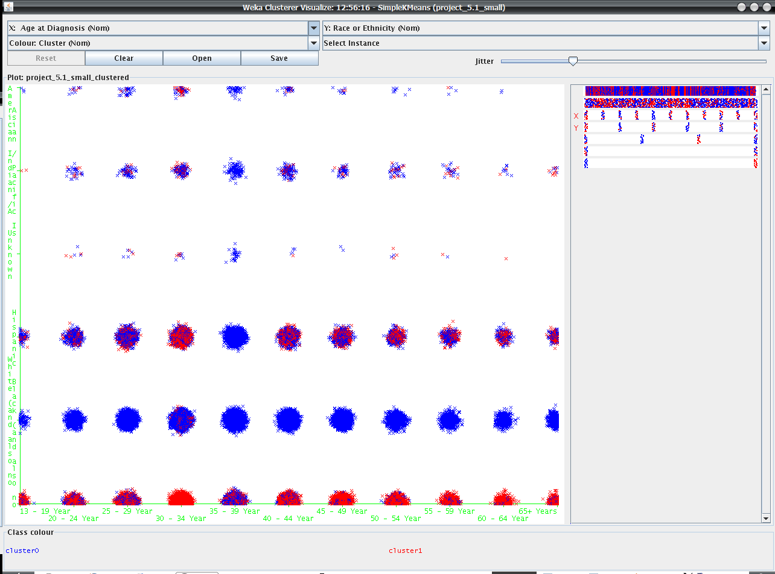
Figure 2
Clusters of age at diagnosis and race or ethnicity with 2 clusters.

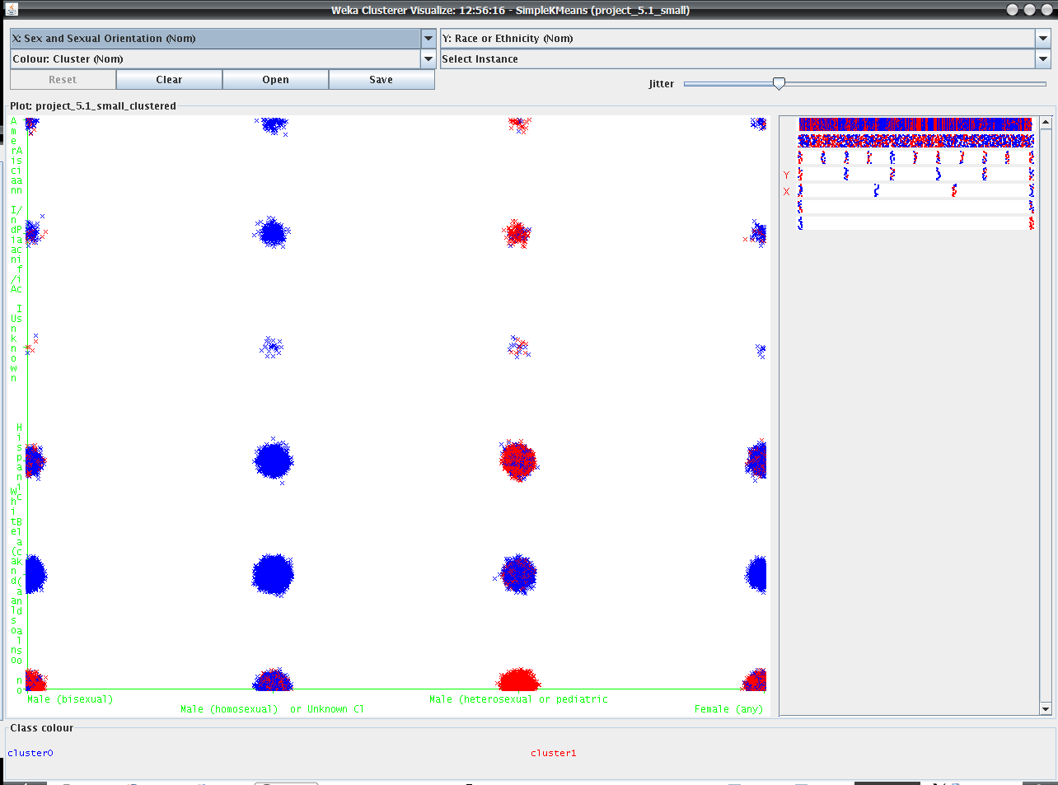
Figure 3
Clusters of sex and sexual orientation and race or ethnicity with 2 clusters.
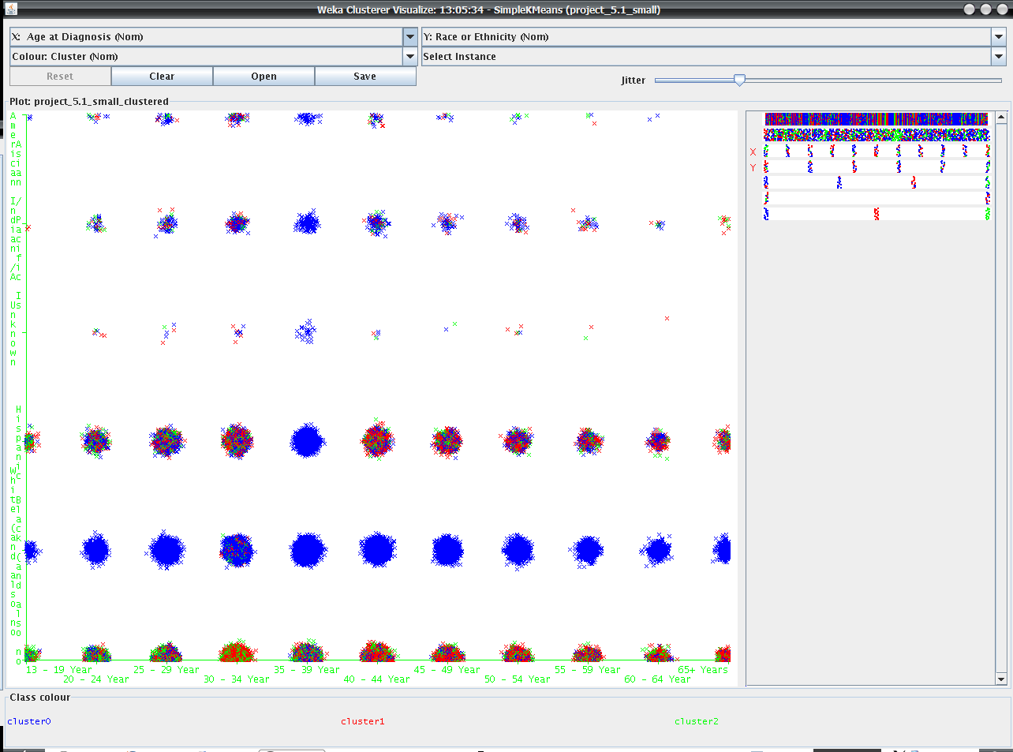
Figure 4
Clusters of age at diagnosis and race or ethnicity with 3 clusters.

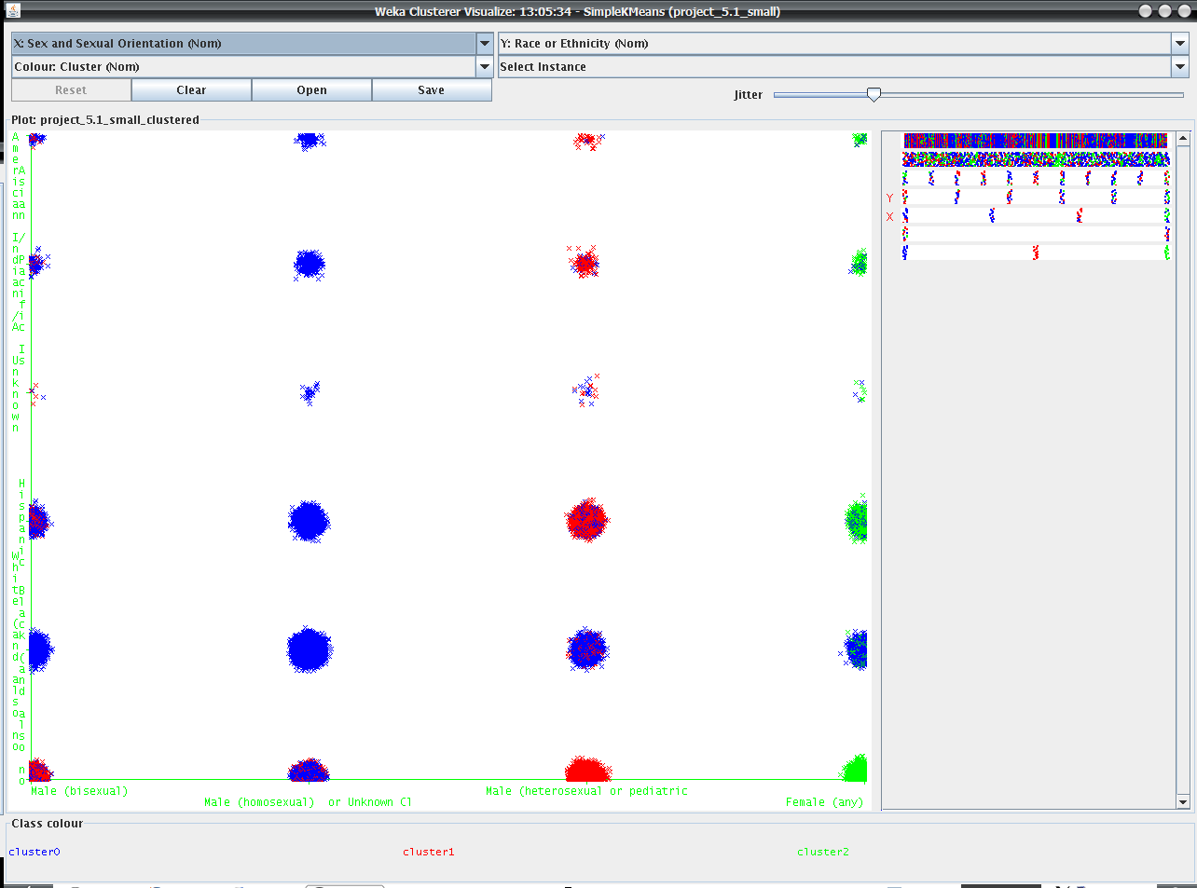
Figure 5
Clusters of sex and sexual orientation and race or ethnicity with 3 clusters.
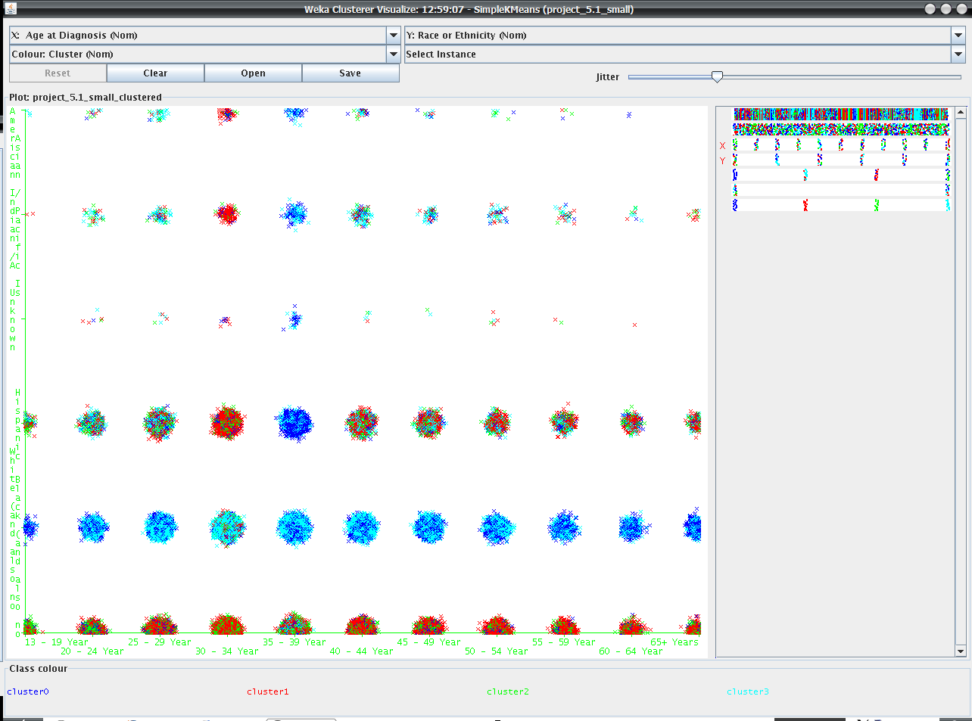
Figure 6
Clusters of age at diagnosis and race or ethnicity with 4 clusters.

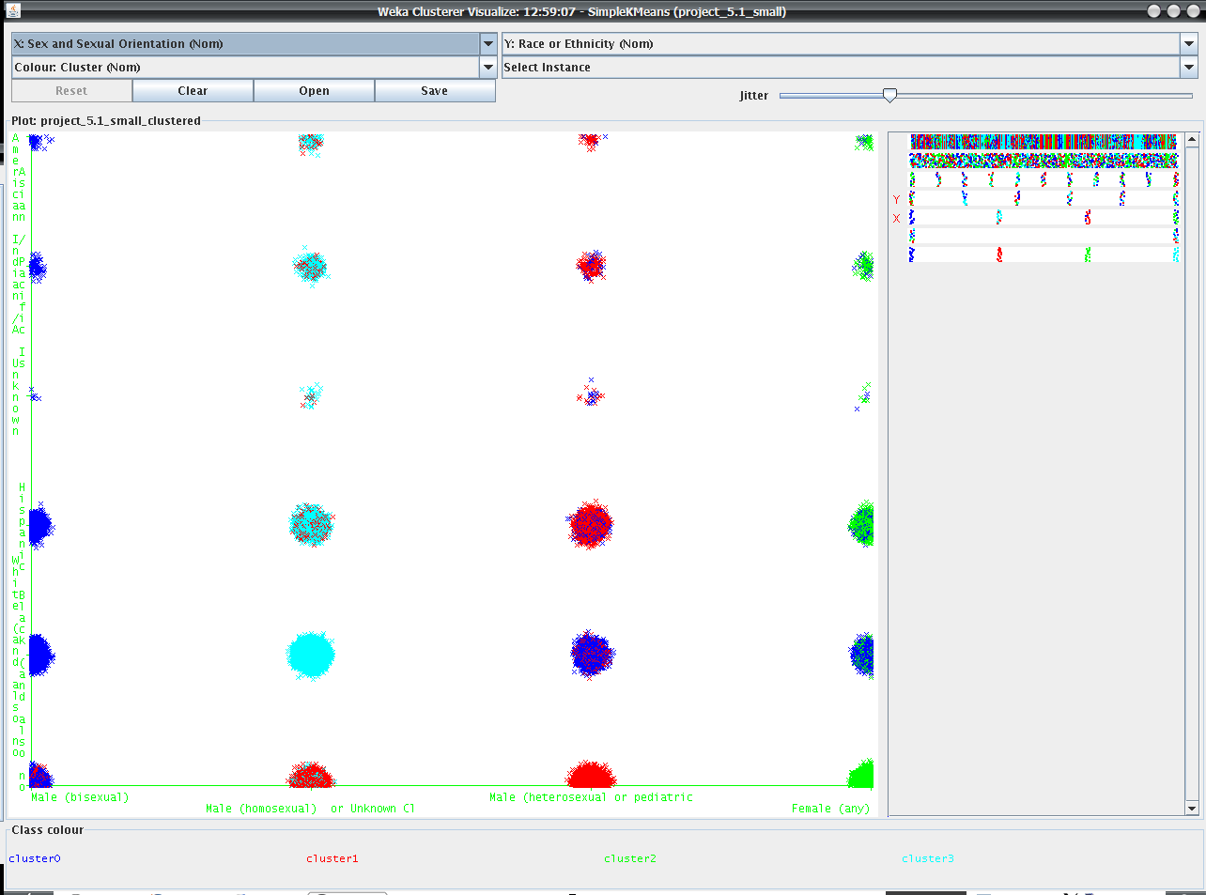
Figure 7
Clusters of sex and sexual orientation and race or ethnicity with 4 clusters.
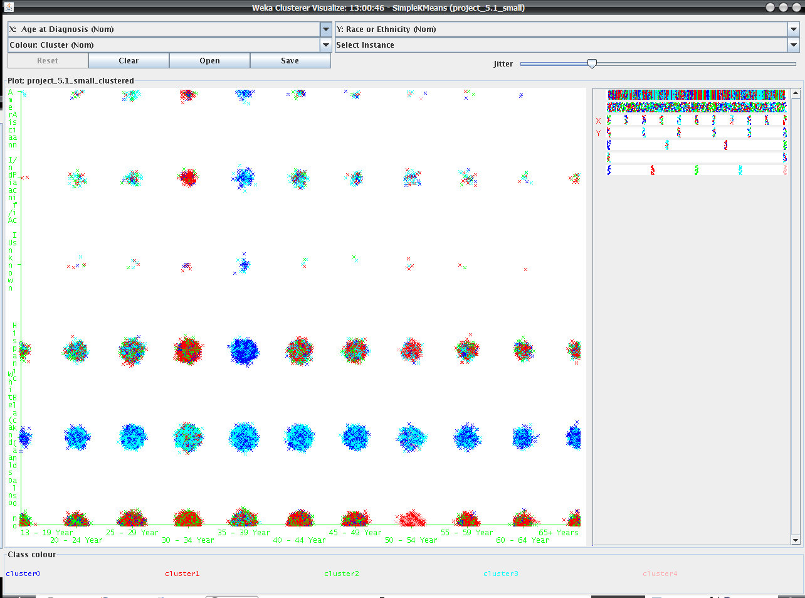
Figure 8
Clusters of age at diagnosis and race or ethnicity with 5 clusters.

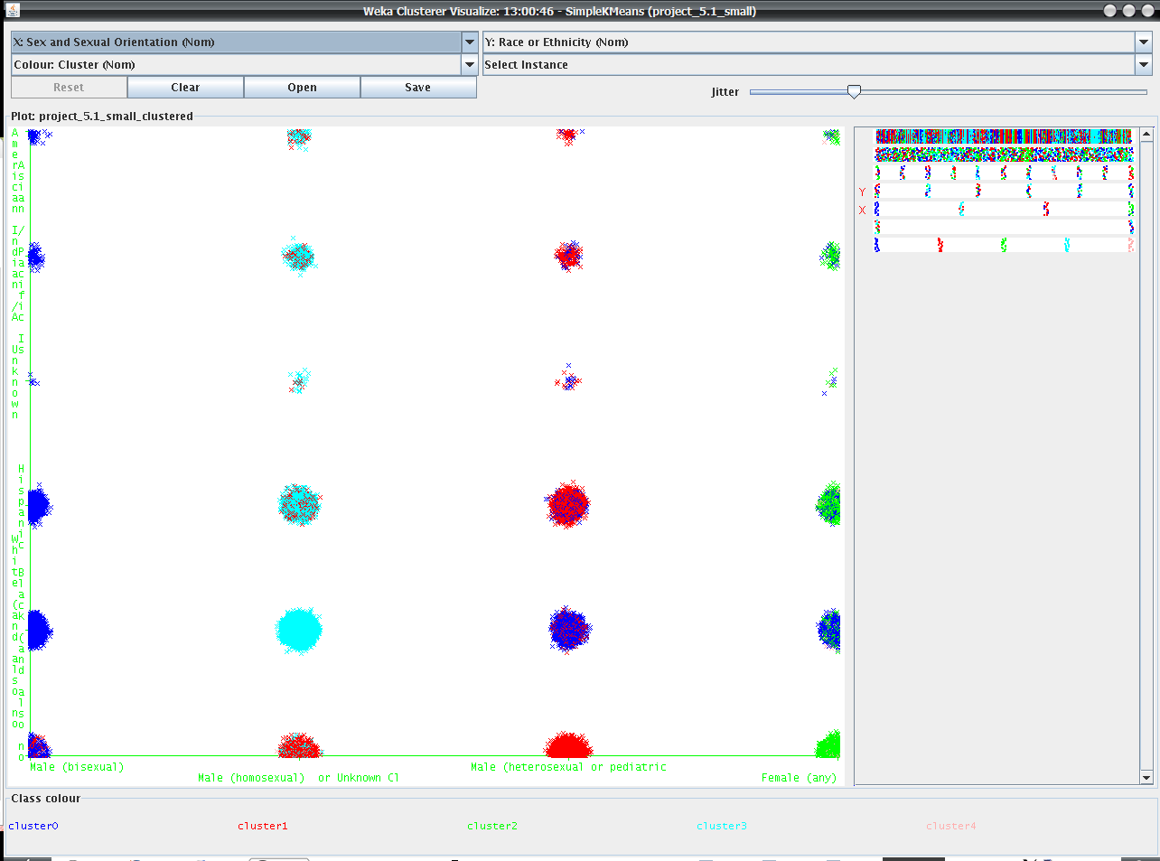
Figure 9
Clusters of sex and sexual orientation and race or ethnicity with 5 clusters.

It is important that you refer to the corresponding output for each clustering in the ./simple_kmeans folder. You will find detailed information on how the clusters were constructed in the run information sections.

Take into consideration that the graphs above have a significant amount of jitter. Because all of the attributes in the dataset are nominal (even the continuous attributes such as age), it was important to visualize the quantity of each cluster relative to each other. With jitter off, you would only see one point for each cluster.

The k means clustering with 2 clusters formed clusters as such:

Cluster: | 1 | 2
Age at Diagnosis: | 35 - 39 Years or age is missing | 30 - 34 Years
Race or Ethnicity: | White (and also not Hispanic) | Black (and also not Hispanic)
Sex and Sexual Orientation: | Male (homosexual) or Unknown Classification | Male (heterosexual or pediatric)

62% of the instances were classified in cluster 0 and 38% in cluster 1.

When examining figure 2, which shows age at diagnosis and race or ethnicity, and figure 3, which shows race or ethnicity and sex and sexual orientation, you can clearly see these clusters in the data in the solid blue and solid red clusters.

When running k means with a k of 3, the same clusters in a k means of k=2 are seen, with the addition of the following cluster:

Cluster: | 3
Age at Diagnosis: | 30 - 34 Years
Race or Ethnicity: | Black (and also not Hispanic)
Sex and Sexual Orientation: | Female (any)

Clustered Instances:
0 45733 ( 57%)
1 23230 ( 29%)
2 11704 ( 15%)

When running kmeans with a k of 4, a similar result is seen as before, where a new cluster is introduced. (Refer to the documentation in ./simple_kmeans for the run output).

Unlike before, a k of 5 in k means results in an insignificant information gain and a small change in the graphs. We interrupt this small change due to the fact that we only have four distinct sex and sexual orientation classes. Therefore sex and sexual orientation may be one of the largest factors in the determination of the risk groups.

Figure 5 and 7 provide some of the most interesting data. In figure 7 you will see that cluster 3 (33% of the records) and cluster 1 (32% of the records) compose about 65% of the records. This suggests that the group composed of white homosexual males ages (age at diagnosis) 35 to 39 and the group composed of black heterosexual males ages (age at diagnosis) 30 to 34 form a large part of the HIV community. Likewise in figure 5, 86% of the records are classified into same groups previously.

We decided to test other clustering algorithms, and focused in on the simple EM (expectation maximisation) class. EM assigns a probability distribution to each instance which indicates the probability of it belonging to each of the clusters. EM can decide how many clusters to create by using cross validation. We ran EM on the dataset while ignoring location, age at diagnosis, and vital status.

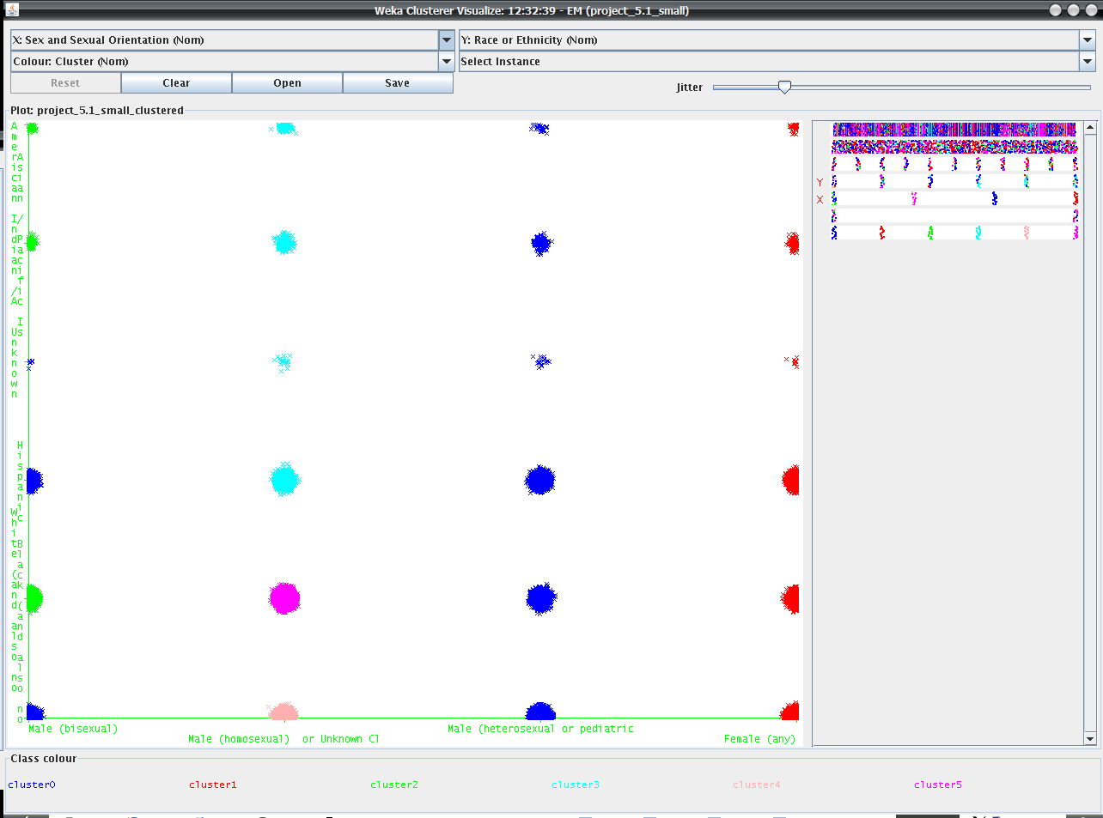
Figure 10
Clusters of sex and sexual orientation and race or ethnicity with 6 clusters using EM.

Expectation maximisation constructed 6 clusters.

Here is a breakdown of the clustered instances

Cluster | Percent of records classified
0 | 36%
1 | 18%
2 | 5%
3 | 6%
4 | 8%
5 | 26%

You should refer to the documentation located in ./em for detailed information and run output.

You can see that clusters 0 and 5 account for 62% of the records. Cluster 0 is primarily composed of heterosexual males. Cluster 5 is entirely composed of white homosexual males.
Consider clusters where the sex and sexual orientation is homosexual (clusters 3, 4, and 5). This group composes 40% of the population. Figure 10 is the strongest indicator, and evidence that homosexual males compose the largest risk group. This backs a portion of the claims made by the articles citing the CDC data. Cluster 4 is entirely composed of black homosexual males, and accounts for 8% of the records. We can not make a claim that this is significantly high. In order to take age into account we reran EM while considering age at diagnosis.

With another set of attributes to consider, EM created 15 clusters and took 7 hours to run. Please refer to ./em/em_age_race_sex_clusters_15.txt for detailed information. Figures 11 and 12 below show some features of the clustering.

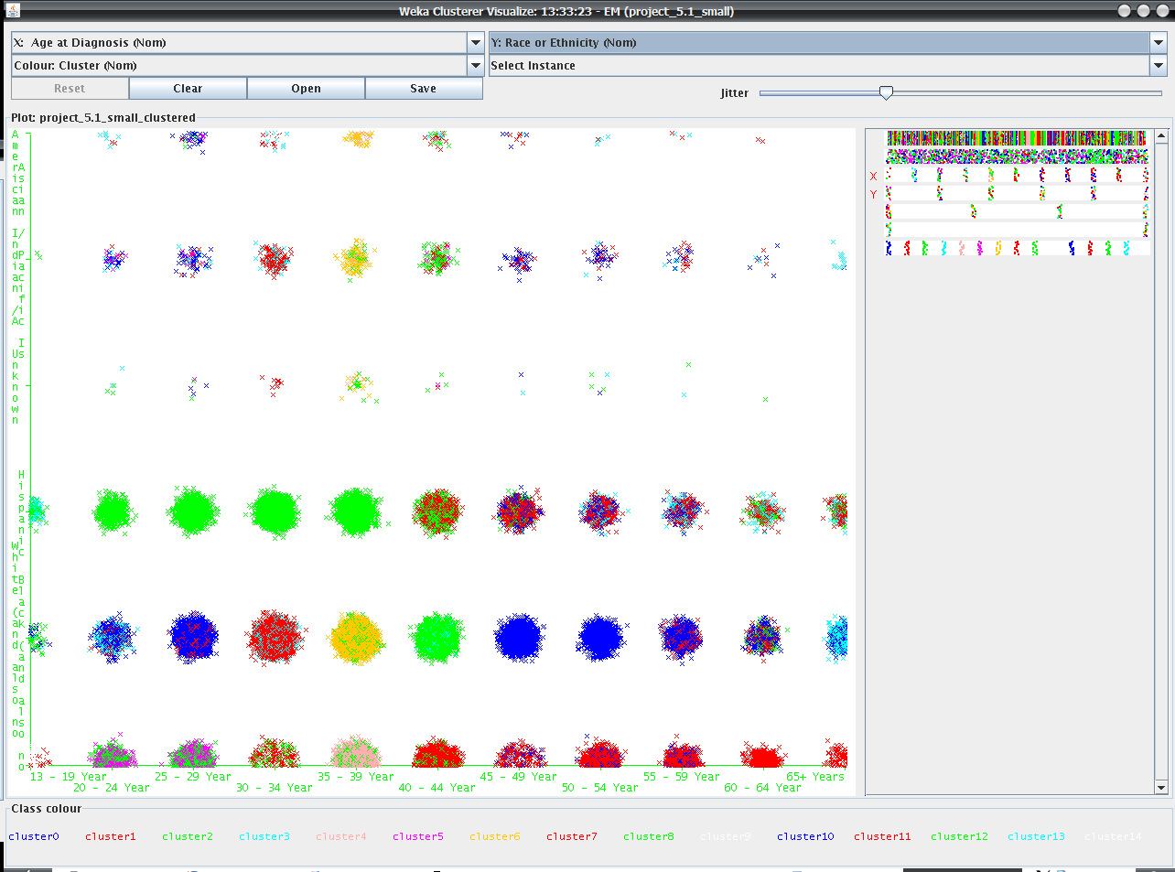
Figure 11
Clusters of age at diagnosis and race or ethnicity with 15 clusters using EM.

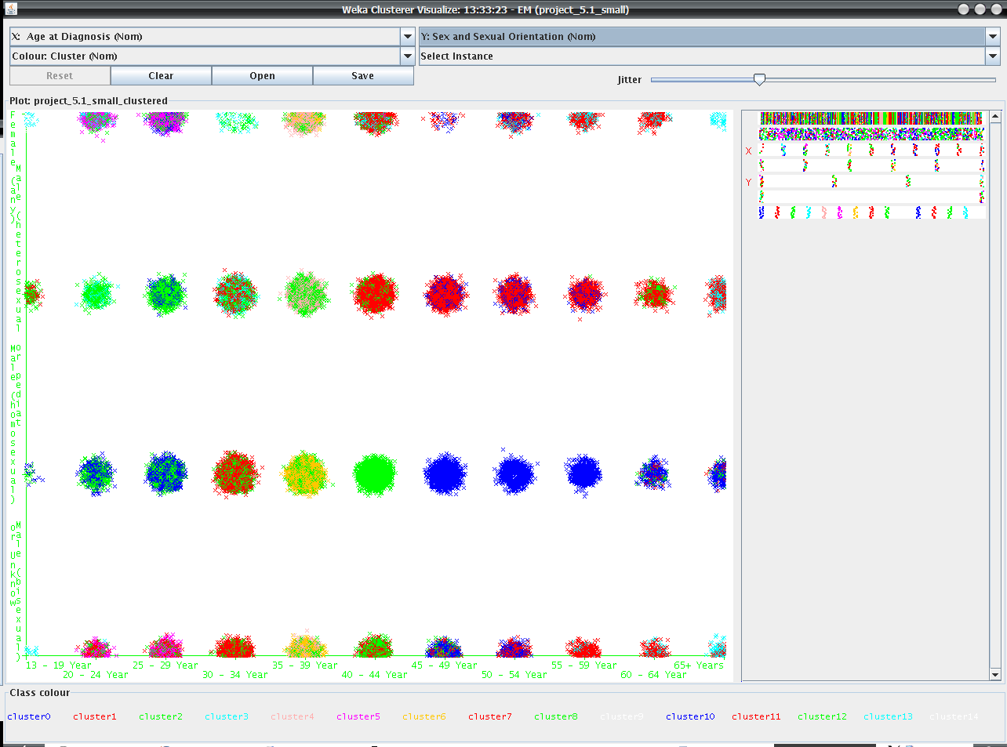
Figure 12
Clusters of age at diagnosis and sex and sexual orientation with 15 clusters using EM.
Cluster 2 is immediately noticed, because it is the largest cluster with 22% of the records, followed by cluster 1 with 18% of the records. The average percentages of the total records of the remaining clusters is 4.6%. Cluster 2 is mainly composed of Black and Hispanic homosexual and heterosexual males, ages (age at diagnosis) 25 to 39. Cluster 1 is mainly composed of Black heterosexual males, (age at diagnosis) 40 to 44 whose sexual orientation is homosexual and heterosexual. Considering that cluster 1 and cluster 2 account for 40% of the records, we are confident that Black males (regardless of sexual orientation) ages 25 to 44 are a high risk group for HIV.

When looking at hierarchical clustering approaches, we were unsure of what to expect. WEKA only offers one algorithm, COBWEB. After experimenting thoroughly with different parameters for the algorithm, we could still not get well defined results. When considering age at diagnosis, race or ethnicity, and sex and sexual orientation COBWEB would produce a scheme with over 200 clusters or only one cluster depending on what was set for the cutoff value. The algorithms seems to be very sensitive to this parameter. We tried many values for the cutoff between 25% and .2%. The best results were at a cutoff of about 16%. Here is the output:

Scheme: weka.clusterers.Cobweb -A 1.0 -C 0.1582094791773878 -S 42
Relation: project_5.1_small
Instances: 80667
Attributes: 5
Age at Diagnosis
Race or Ethnicity
Sex and Sexual Orientation
Ignored:
Location
Vital Status
Test mode: evaluate on training data

=== Model and evaluation on training set ===

Number of merges: 270
Number of splits: 265
Number of clusters: 14

node 0 [80667]
| leaf 1 [33528]
node 0 [80667]
| node 2 [15372]
| | leaf 3 [4692]
| node 2 [15372]
| | leaf 4 [6119]
| node 2 [15372]
| | node 5 [4561]
| | | leaf 6 [2856]
| | node 5 [4561]
| | | leaf 7 [1705]
node 0 [80667]
| node 8 [31767]
| | leaf 9 [12785]
| node 8 [31767]
| | node 10 [10117]
| | | leaf 11 [6648]
| | node 10 [10117]
| | | leaf 12 [3469]
| node 8 [31767]
| | leaf 13 [8865]

Clustered Instances

1 33529 ( 42%)
3 4690 ( 6%)
4 6102 ( 8%)
6 2857 ( 4%)
7 1706 ( 2%)
9 12799 ( 16%)
11 6648 ( 8%)
12 3471 ( 4%)
13 8865 ( 11%)
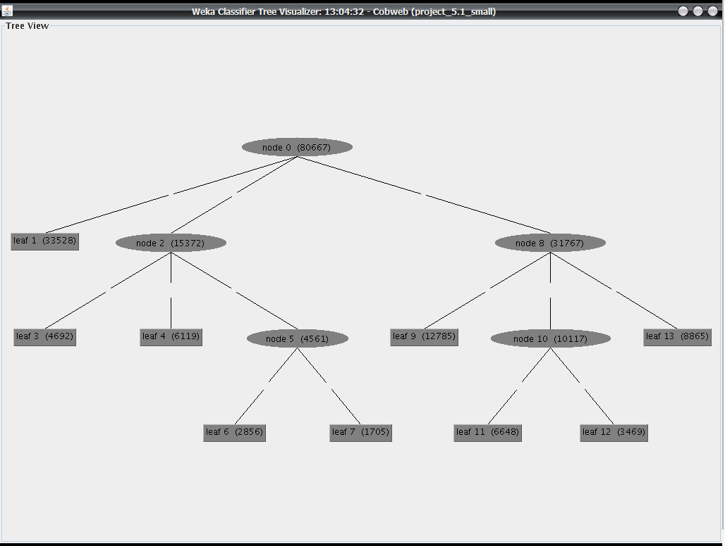
Figure 13
COBWEB tree.

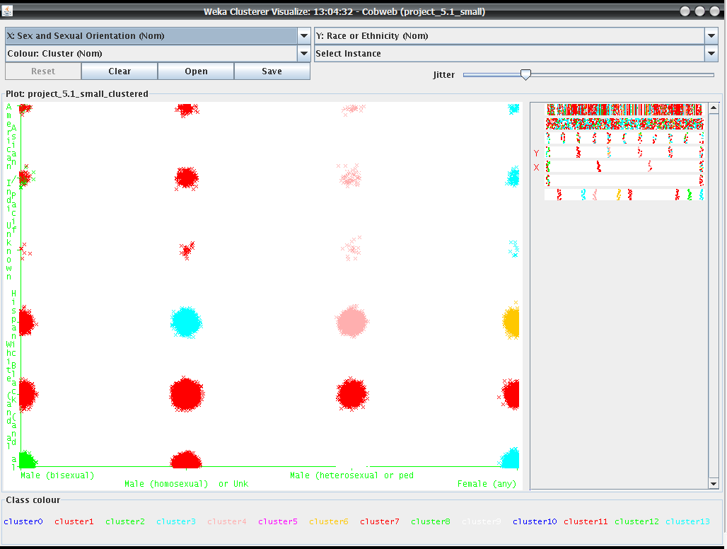
Figure 14
Clusters of race or ethnicity and sex and sexual orientation using COBWEB.

We are unsure how to interpret the results. Cluster one contains 42% of the records and is composed of mainly black males.

Conclusion:

Overall the best data mining strategy for our data was a sophisticated clustering algorithm. EM provided the best meaningful results, and backs a portion of the claims made by the articles** we found. Although the clean results of the clustering algorithm are presented above it is important to consider the validity and accuracy of the data as well. Surely some uncertainty and unreliability should be considered and factored into the results. We learned about the application of general data mining processes on a true set of data, and what work is associated with this process. If we were to continue exploring and mining this data set we would look more into different clustering algorithms and the patterns they provide. An ultimate goal centered around the topic of HIV and this dataset would be to construct a model that could predict the risk of HIV for a particular individual, based on one’s attributes.

**Sources: http://www.dispatch.com/live/content/local_news/stories/2008/09/12/HIVDATA.ART_ART_09-12-08_A1_NOBA6T2.html

http://www.cnn.com/2008/HEALTH/conditions/09/12/hiv.blacks.gays/index.html

